Functional Specification – General Report Requirements

Export-Import Bank of Thailand

|  |  |
| --- | --- |
| Project Code: | <EXPJ.B.PJ.TH.EXIMTH*CBS_IMP.CC> |
| Reference: | <Client BZ Reference and Description> |
| Release: | 2.0 |
| Status: | Draft for Client Review |
| Date | 3-Aug-23 |

Contents

Introduction 19

Functional Summary 23

Report Specification 23

1. Credit Advice Report - Create Limit Loan 23

1.1. Purpose 23

1.2. Background 23

1.3. Supported Sample Transaction and Case from Customer 24

1.4. Menu Modification 25

1.5. Screen Layout and Data Sheet 25

1.6. Business Rule / Business Logic 26

1.7. To-be Processing 26

1.8. File /API Layout and Data Sheet 26

1.9. Report Layout and Data Sheet 26

1.10. Additional Impacts 28

2. Credit Advice Report - Credit Limit O/D 29

2.1. Purpose 29

2.2. Background 29

2.3. Supported Sample Transaction and Case from Customer 30

2.4. Menu Modification 30

2.5. Screen Layout and Data Sheet 30

2.6. Business Rule / Business Logic 30

2.7. To-be Processing 31

2.8. File /API Layout and Data Sheet 31

2.9. Report Layout and Data Sheet 31

2.10. Additional Impacts 32

3. Credit Advice Report - Loan Group Limit 33

3.1. Purpose 33

3.2. Background 33

3.3. Supported Sample Transaction and Case from Customer 34

3.4. Menu Modification 36

3.5. Screen Layout and Data Sheet 36

3.6. Business Rule / Business Logic 36

3.7. To-be Processing 37

3.8. File /API Layout and Data Sheet 37

3.9. Report Layout and Data Sheet 37

3.10. Additional Impacts 39

4. Credit Advice Report - Increase Limit (Loan and O/D) 39

4.1. Purpose 39

4.2. Background 40

4.3. Supported Sample Transaction and Case from Customer 40

4.4. Menu Modification 41

4.5. Screen Layout and Data Sheet 41

4.6. Business Rule / Business Logic 41

4.7. To-be Processing 42

4.8. File /API Layout and Data Sheet 42

4.9. Report Layout and Data Sheet 42

4.10. Additional Impacts 44

5. Credit Advice Report - Decrease Limit (Loan and O/D) 44

5.1. Purpose 44

5.2. Background 45

5.3. Supported Sample Transaction and Case from Customer 45

5.4. Menu Modification 45

5.5. Screen Layout and Data Sheet 46

5.6. Business Rule / Business Logic 46

5.7. To-be Processing 46

5.8. File /API Layout and Data Sheet 46

5.9. Report Layout and Data Sheet 46

5.10. Additional Impacts 48

6. Credit Advice Report - Change Limit Conditions (Loan and O/D) 48

6.1. Purpose 49

6.2. Background 49

6.3. Supported Sample Transaction and Case from Customer 50

6.4. Menu Modification 52

6.5. Screen Layout and Data Sheet 52

6.6. Business Rule / Business Logic 52

6.7. To-be Processing 53

6.8. File /API Layout and Data Sheet 53

6.9. Report Layout and Data Sheet 53

6.10. Additional Impacts 55

7. Credit Advice Report - Hold Limit (Loan and O/D) 55

7.1. Purpose 55

7.2. Background 56

7.3. Supported Sample Transaction and Case from Customer 56

7.4. Menu Modification 57

7.5. Screen Layout and Data Sheet 57

7.6. Business Rule / Business Logic 57

7.7. To-be Processing 57

7.8. File /API Layout and Data Sheet 58

7.9. Report Layout and Data Sheet 58

7.10. Additional Impacts 59

8. Credit Advice Report - Unhold Limit (Loan and O/D) 59

8.1. Purpose 59

8.2. Background 60

8.3. Supported Sample Transaction and Case from Customer 60

8.4. Menu Modification 60

8.5. Screen Layout and Data Sheet 61

8.6. Business Rule / Business Logic 61

8.7. To-be Processing 61

8.8. File /API Layout and Data Sheet 61

8.9. Report Layout and Data Sheet 61

8.10. Additional Impacts 63

9. Credit Advice Report - Cancel Limit (Loan and O/D) 63

9.1. Purpose 63

9.2. Background 63

9.3. Supported Sample Transaction and Case from Customer 64

9.4. Menu Modification 65

9.5. Screen Layout and Data Sheet 65

9.6. Business Rule / Business Logic 65

9.7. To-be Processing 65

9.8. File /API Layout and Data Sheet 66

9.9. Report Layout and Data Sheet 66

9.10. Additional Impacts 67

10. Daily Report 68

10.1. Purpose 68

10.2. Background 68

10.3. Supported Sample Transaction and Case from Customer 68

10.4. Menu Modification 69

10.5. Screen Layout and Data Sheet 69

10.6. Business Rule / Business Logic 69

10.7. To-be Processing 69

10.8. File /API Layout and Data Sheet 69

10.9. Report Layout and Data Sheet 69

10.10. Additional Impacts 71

11. Monthly Report 71

11.1. Purpose 71

11.2. Background 71

11.3. Supported Sample Transaction and Case from Customer 71

11.4. Menu Modification 71

11.5. Screen Layout and Data Sheet 72

11.6. Business Rule / Business Logic 72

11.7. To-be Processing – 72

11.8. File /API Layout and Data Sheet 72

11.9. Report Layout and Data Sheet 72

11.10. Additional Impacts 73

12. Approval credit limit report 74

12.1. Purpose 74

12.2. Background 74

12.3. Supported Sample Transaction and Case from Customer 74

12.4. Menu Modification 75

12.5. Screen Layout and Data Sheet 75

12.6. Business Rule / Business Logic 75

12.7. To-be Processing 76

12.8. File /API Layout and Data Sheet 77

12.9. Report Layout and Data Sheet 77

12.10. Additional Impacts 78

13. Sign contract report 78

13.1. Purpose 78

13.2. Background 79

13.3. Supported Sample Transaction and Case from Customer 79

13.4. Menu Modification 80

13.5. Screen Layout and Data Sheet 80

13.6. Business Rule / Business Logic 80

13.7. To-be Processing 80

13.8. File /API Layout and Data Sheet 81

13.9. Report Layout and Data Sheet 81

13.10. Additional Impacts 82

14. Cancellation report 83

14.1. Purpose 83

14.2. Background 83

14.3. Supported Sample Transaction and Case from Customer 83

14.4. Menu Modification 84

14.5. Screen Layout and Data Sheet 84

14.6. Business Rule / Business Logic 84

14.7. To-be Processing 85

14.8. File /API Layout and Data Sheet 85

14.9. Report Layout and Data Sheet 85

14.10. Additional Impacts 87

15. Not sign contract report 87

15.1. Purpose 87

15.2. Background 87

15.3. Supported Sample Transaction and Case from Customer 87

15.4. Menu Modification 88

15.5. Screen Layout and Data Sheet 88

15.6. Business Rule / Business Logic 88

15.7. To-be Processing 88

15.8. File /API Layout and Data Sheet 88

15.9. Report Layout and Data Sheet 88

15.10. Additional Impacts 90

16. Limit and outstanding report 90

16.1. Purpose 90

16.2. Background 90

16.3. Supported Sample Transaction and Case from Customer 90

16.4. Menu Modification 91

16.5. Screen Layout and Data Sheet 91

16.6. Business Rule / Business Logic 91

16.7. To-be Processing 91

16.8. File /API Layout and Data Sheet 92

16.9. Report Layout and Data Sheet 92

16.10. Additional Impacts 94

17. Revolving credit limit (According to the limit user) report (Included in TOR, have to discuss) 94

17.1. Purpose 94

17.2. Background 94

17.3. Supported Sample Transaction and Case from Customer 95

17.4. Menu Modification 95

17.5. Screen Layout and Data Sheet 95

17.6. Business Rule / Business Logic 95

17.7. To-be Processing 95

17.8. File /API Layout and Data Sheet 96

17.9. Report Layout and Data Sheet 96

17.10. Additional Impacts 96

18. Report of the Accumulate Credit Limit Amount Summary Report (Included in TOR, have to discuss) 97

18.1. Purpose 97

18.2. Background 97

18.3. Supported Sample Transaction and Case from Customer 97

18.4. Menu Modification 100

18.5. Screen Layout and Data Sheet 100

18.6. Business Rule / Business Logic 100

18.7. To-be Processing 101

18.8. File /API Layout and Data Sheet 101

18.9. Report Layout and Data Sheet 101

18.10. Additional Impacts 101

19. Summary report of business types (Included in TOR, have to discuss) 101

19.1. Purpose 101

19.2. Background 101

19.3. Supported Sample Transaction and Case from Customer 102

19.4. Menu Modification 102

19.5. Screen Layout and Data Sheet 102

19.6. Business Rule / Business Logic 103

19.7. To-be Processing 103

19.8. File /API Layout and Data Sheet 103

19.9. Report Layout and Data Sheet 103

19.10. Additional Impacts 103

20. Risk Weight report 104

20.1. Purpose 104

20.2. Background 104

20.3. Supported Sample Transaction and Case from Customer 104

20.4. Menu Modification 104

20.5. Screen Layout and Data Sheet 104

20.6. Business Rule / Business Logic 104

20.7. To-be Processing 104

20.8. File /API Layout and Data Sheet 105

20.9. Report Layout and Data Sheet 105

20.10. Additional Impacts 106

21. Loan amount that have not drawdown report (classified by credit line users) 106

21.1. Purpose 106

21.2. Background 106

21.3. Supported Sample Transaction and Case from Customer 107

21.4. Menu Modification 107

21.5. Screen Layout and Data Sheet 107

21.6. Business Rule / Business Logic 107

21.7. To-be Processing 108

21.8. File /API Layout and Data Sheet 108

21.9. Report Layout and Data Sheet 108

21.10. Additional Impacts 109

22. Decreasing Limits report 110

22.1. Purpose 110

22.2. Background 110

22.3. Supported Sample Transaction and Case from Customer 110

22.4. Menu Modification 110

22.5. Screen Layout and Data Sheet 110

22.6. Business Rule / Business Logic 110

22.7. To-be Processing 110

22.8. File /API Layout and Data Sheet 111

22.9. Report Layout and Data Sheet 111

22.10. Additional Impacts 112

23. Report Reconcile 113

23.1. Purpose 113

23.2. Background 113

23.3. Supported Sample Transaction and Case from Customer 113

23.4. Menu Modification 113

23.5. Screen Layout and Data Sheet 113

23.6. Business Rule / Business Logic 113

23.7. To-be Processing 113

23.8. File /API Layout and Data Sheet 113

23.9. Report Layout and Data Sheet 113

23.10. Additional Impacts 113

Document Acceptance & Release Notice

This is a managed document. Changes will only be issued as a complete replacement document covered by a release notice. All replaced documents shall be destroyed immediately and copies of any obsolete forms destroyed. This document has not been released for use until authorized by the Manager/Project Manager.

This is release 2.0 of the document.

|  |  |  |  |
| --- | --- | --- | --- |
| Reviewed & Approved |  | Date |  |
|  | | | |
| Accepted |  | Date |  |
|  | |  |  |
| Authorized |  | Date |  |
|  | | | |

Build Status

|  |  |  |  |
| --- | --- | --- | --- |
| Release | Date of Release | Prepared by | Comments |
| 1.0 | 05-June-2023 | Teerapat Kongrit | Consolidated various Limit report requirements |
| 1.1 | 26-July-2023 | Emy Bartolome | Incorporated purpose, To be process for logic on data source of reports & standardized sections |
| 1.2 | 27-Jul-2023 | Emy Bartolome | Minor changes to include Facility Verify + logic to retrieve loan data |
| 2.0 | 03-Aug-2023 | Emy Bartolome | Incorporated additional changes on logic for Credit Advice and other report |

# 

# Introduction

CBS Foundation and Enterprise workshop activity was conducted at the Export-Import Bank (EXIM) of Thailand highlighted all requirements related to issue credit limit report by using the information in the report. The report layout shown in this document are currently in use by Business Unit.Abbreviations

The following list defines the abbreviations used in this document.

|  |  |
| --- | --- |
| EXIM | Export Import Bank of Thailand |
| TOR | Terms of Reference |
| AS/400 | EXIM Core Legacy System |
| LOS | EXIM Loans Origination System |
| CRM | EXIM Customer Relations Module |
| SSI | Silverlake Symmetri |
| CBS | Silverlake Symmetri Core Banking System |
| CSD | CBS Common Static Data Module |
| ENT | CBS Enterprise Modules |
| MCL | CBS Customer Module |
| LMT | CBS Limits Module |
| BPM | CBS Business Process Management |
| LND | CBS Lending Module |
| DEP | CBS Deposits Module |
| GFT | CBS Global Funds Transfer Module |
| THB | Thai Baht |

References

|  |  |  |  |
| --- | --- | --- | --- |
| ID | Title/Summary | TOR Status | Module |
| TOR-CD-13 | Able to display customer information in the specified format, such as information classified by type of customer or separated according to the credit limit of the customer, etc.  สามารถแสดงข้อมูลลูกค้าตามรูปแบบที่กำหนด เช่น ข้อมูลแยกตามประเภทของลูกค้า หรือแยกตามวงเงินของลูกค้า เป็นต้น |  | Query/Report/Form |
| TOR-CD-35 | Able to issued reports of customers who are overdue for a specified period of time, such as over 30 days, over 90, etc.  สามารถเรียกดูรายงานลูกค้าที่ OverDue ตามระยะเวลาที่กำหนดได้ เช่น เกิน 30 วัน, เกิน 90 เป็นต้น |  | Query/Report/Form |
| TOR-CD-36 | Able to produce a report showing corrections, changes, increases, decreases, cancels the credit limit by specifying the search period. and can issue reports for a period of time  สามารถจัดทำรายงานแสดงการแก้ไข เปลี่ยนแปลง เพิ่ม ลด ยกเลิก Credit Limit โดยกำหนดช่วงระยะเวลาในการค้นหา และออกรายงานตามช่วงระยะเวลาได้ | Customization | Reports |
| TOR-CD-37 | Able to inquiry (Report) daily reports.  สามารถเรียกดู (Report) รายงานประจำวัน | Closed-Supported | Reports |
| TOR-CD-58 | able to search for credit limit information in a variety of formats, such as according to customers, according to the limit, and can show information of the limit, such as the approved limit available limit Hold limit Terms of the limit Outstanding of the limit Available balance  สามารถค้นหาข้อมูลวงเงินได้หลากหลายรูปแบบ เช่น ตามลูกค้า ตามวงเงิน และสามารถแสดงข้อมูลของวงเงิน เช่น วงเงินอนุมัติ วงเงินที่ใช้ได้ วงเงินที่ถูกระงับ เงื่อนไขของวงเงิน ภาระคงค้างของวงเงิน ยอดวงเงินคงเหลือที่ใช้ได้ |  |  |
| TOR-CD-61 | Able to issue a credit limit advice report after recording/approving transactions and can be issued retrospectively can be issued in PDF File format.  สามารถออกใบตั้งวงเงินหลังจากบันทึกรายการ/อนุมัติรายการ และสามารถออกย้อนหลังได้ โดยออกในรูปแบบ PDF File ได้ | Customization | Reports |
| TOR-CD-62 | inquiry (Report) Monthly report.  สามารถเรียกดู (Report) รายงานประจำเดือน | Customization | Reports |
| TOR-CD-63 | Able to Inquiry (Report) Report the Approved credit line which classify by Marketing Department  สามารถเรียกดู (Report) รายงานอนุมัติสินเชื่อตามผู้ดูแล | Customization | Reports |
| TOR-CD-64 | Able to Inquiry (Report) W25_06_2020  สามารถเรียกดู (Report) W25_06_2020 | Customization | Reports |
| TOR-CD-65 | Able to Inquiry (Report) Report on cancellation of credit limit  สามารถเรียกดู (Report) รายงานการยกเลิก/ปลดภาระวงเงิน | Customization | Reports |
| TOR-CD-66 | Able to Inquiry (Report) Report on credit approval have not yet signed a contract which classify by Marketing Department  สามารถเรียกดู (Report) รายงานการอนุมัติสินเชื่อไม่เซ็นสัญญาตามผู้ดูแลวงเงิน | Customization | Reports |
| TOR-CD-67 | Able to Inquiry (Report) report the credit line signed contract in the month  สามารถเรียกดู (Report) รายงานวงเงินที่เซ็นสัญญาในเดือน | Customization | Reports |
| TOR-CD-71 | Able to Inquiry (Report) Report of accumulated limit and outstanding balances of the limit  สามารถเรียกดู (Report) รายงานวงเงินสะสมและยอดคงค้าง | Customization | Reports |
| TOR-CD-72 | Able to Inquiry (Report) Risk Weight  สามารถเรียกดู (Report) Risk Weight | Customization | Reports |
| TOR-CD-73 | Able to Inquiry (Report) Loan Credit Limit (Sort by Name)  สามารถเรียกดู (Report) Loan Credit Limit (Sort by Name) | Customization | Reports |

# Functional Summary

This section provides a functionality list of the software product or any modifications on existing Symmetri CBS product.

|  |  |  |
| --- | --- | --- |
| ID | Title/Summary | References |
| FS_EXIMTH_ENT FS07 | Report | TOR |

# Report Specification

## Credit Advice Report - Create Limit Loan

### Purpose

The purpose of this document is to provide the solution approach in order to support generation of Credit Advice Report – Credit Limit Loan.

The Credit Limit Loan that belong to credit advice report is generated for these purposes:

* Send/notify the limit conditions details to operation team for drawdown.
* Others department can use this report for their purpose for example: legal department/maketing department can use this report as references for the completeness of create limit
* To be the reference document for histortical transaction that related limit

### Background

#### EXIM Current Business Pracitce (as is)

* As is report produced in AS/400
* Sample report in Support Sample Transaction and Case from Customer section

### Supported Sample Transaction and Case from Customer

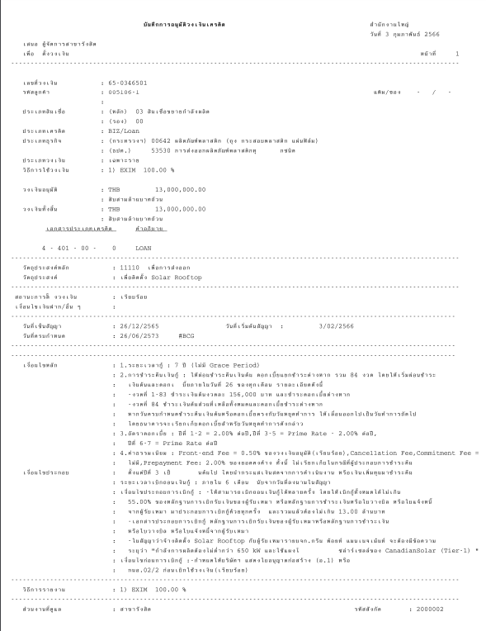

Facility Verify

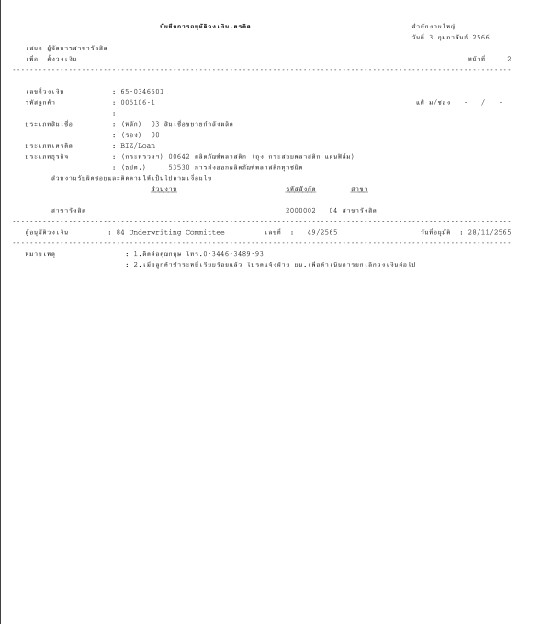

### Menu Modification

Not applicable

### Screen Layout and Data Sheet

Not Applicable

### Business Rule / Business Logic

* Daily / Adhoc / On-demand report
* Report Paramter criteria

| Paper Size | A4 |
| --- | --- |
| Reprinting Require | Yes |
| Searching Criteria | Customer ID, Customer Name, Limit ID, Date, Date range |

### To-be Processing

As basis for generating the report, system will retrieve information from CBS Limits Facility function with details on:

* Limit Facility Details with transaction code: Create
* Description of products (Major/Minor) from business module static configuration set up screens
* Narrative Conditions needs to be retrieved from linked loan account that was created automatically during the time the limit facility was created
  + To link the loan account, CBS to use the following parameters:

1. Customer Code
2. Loan Account having same Major/Minor of the limit facility based on Limit ID
3. Loan Account status = New / Not Drawn / Drawn Amount = 0

### File /API Layout and Data Sheet

Not Applicable

### Report Layout and Data Sheet

| Screen/Report Field Name/Attributes (AS400) | Sample Data (AS400) | Source / Validation |
| --- | --- | --- |
| Header |  |  |
| Report Title | Credit Approval Record |  |
| Branch |  |  |
| System Date |  |  |
| Proposed to:  Relationship Manager |  |  |
| Action: | Create Limit |  |
| Page |  |  |
| **Details** |  |  |
| Transaction Code | Create Limit |  |
| Limit ID | 650346501 |  |
| Loan Account Number |  |  |
| Customer ID | 0051061 |  |
| Facility Verified (Y/N) |  | On BPM-approved, this will be N  On Limit approved, this will be Y |
| Customer Thai Name | Title+Customer Thai Name |  |
| Customer English Name |  |  |
| Major Credit Code + Minor Credit Code | 03 00 |  |
| Major/Minor Description | Capacity Expansion |  |
| Limit Description | Loan |  |
| Product Program | BIZ |  |
| Business Code: | 00642 ผลิตภัณฑ์พลาสติก (ถุง กระสอบพลาสติก แผ่นฟิล์ม) |  |
| BOT Business Code : | 53530 การส่งออกผลิตภัณฑ์พลาสติกทุกชนิด |  |
| Credit Type | Specific Project Limit |  |
| Currency | USD |  |
| Limit Amount | 8,000,000.00 |  |
| Source of Fund and Ratio | GSB 100% |  |
| Main Purpose Code | 11110 เพื่อการส่งออก |  |
| Business Type | ติดตั้ง Solar Rooftop |  |
| Condition Deposit | Deposit as collateral in the amount of MTHB 2.00 |  |
| Interest | 1st year = 3.50% 2nd-4th = Prime Rate + 1.0% |  |
| Fee | Fron end Fee = 1.0% Prepayment Fee = 2.0% Cancellation Fee = 0.5% Commitment Fee = 1.0% |  |
| Contract sign Date | 26/12/2022 |  |
| Effective Date | 3/2/2023 |  |
| Expiry Date | 26/6/2030 |  |
| Authorize No. | 49/2022 |  |
| Authorize Level | 84 Underwriting Committee |  |
| Authorize Date | 28/11/2023 |  |
| Customer Type | Non-Resident |  |
| Country of Risk | JP Japan |  |
| Ratio of Risk | 1.00 |  |
| Business size | L Large |  |
| Major Condition |  |  |
| Minor Condition |  |  |
| Condition Pre Approve |  |  |
| Condition Other |  |  |
| Hashtag | #BCG |  |
| Marketing Division | ส่วนอุตสาหกรรม 5.1 |  |
| Operation Branch | Rama IV Branch |  |
| Credit Limit Remark | ติดต่อคุณไพรัตน์ โทร.0-2194-6000 |  |

### Additional Impacts

##### System Interface requirement /Integration

Not Applicable

##### Migration

Not Applicable

##### Fit/Gap Analysis Report

Not Applicable

## Credit Advice Report - Credit Limit O/D

### Purpose

The purpose of this document is to provide the solution approach in order to support generation of Credit Advice Report – Credit Limit O/D.

The Credit Limit O/D that belong to credit advice report is generated for these purposes:

* Send/notify the limit conditions details to operation team for drawdown.
* Others department can use this report for their purpose for example: legal department/marketing department can use this report as references for the completeness of create limit
* To be the reference document for histortical transaction that related limit

### Background

#### EXIM Current Business Pracitce (as is)

* As is report produced in AS/400
* Sample report in Support Sample Transaction and Case from Customer section

### Supported Sample Transaction and Case from Customer

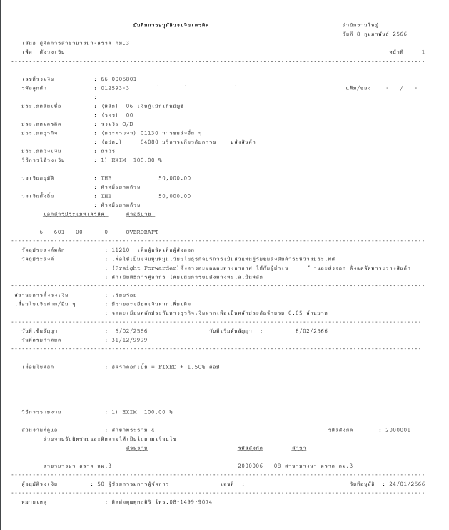

Facility Verify

### Menu Modification

Not applicable

### Screen Layout and Data Sheet

Not Applicable

### Business Rule / Business Logic

* Daily / Adhoc / On-demand report
* Report Paramter criteria

| Paper Size | A4 |
| --- | --- |
| Reprinting Require | Yes |
| Searching Criteria | Customer ID, Customer Name, Limit ID, Date, Date range |

### To-be Processing

As basis for generating the report, system will retrieve information from CBS Limits Facility function with details on:

* Limit Facility Details with transaction code: Create and Limit facility code is linked to product code where business domain = DEPOSIT
* Description of products (Major/Minor) from business module static configuration set up screens
* Narrative Conditions needs to be retrieved from O/D limit facility.

### File /API Layout and Data Sheet

Not applicable

### Report Layout and Data Sheet

| Screen/Report Field Name/Attributes (AS400) | Sample Data (AS400) | Source/Validations |
| --- | --- | --- |
| **Header** |  |  |
| Report Title | Credit Approval Record |  |
| Branch |  |  |
| System Date |  |  |
| Proposed to : Relationship Manager |  |  |
| Action : | Create Limt |  |
| Page |  |  |
| **Details** |  |  |
| Transaction Code | Create Limit |  |
| Limit ID | 650346501 |  |
| Customer ID | 0051061 |  |
| Facility Verified Y/N |  | On BPM-approved, this will be N  On Limit approved, this will be Y |
| Customer Thai Name | Title+Customer Thai Name |  |
| Customer English Name |  |  |
| Major Credit Code + Minor Credit Code | 06 00 |  |
| Major/Minor Description | Overdraft |  |
| Limit Description | วงเงิน O/D |  |
| Product Program |  |  |
| Business Code: | 01130 การขนส่งอื่น ๆ |  |
| BOT Business Code : | 84080 บริการเกี่ยวกับการขนส่งสินค้า |  |
| Credit Type | Permanent Limit |  |
| Currency | THB |  |
| Limit Amount | 50000 |  |
| Source of Fund and Ratio | EXIM 100% |  |
| Main Purpose Code | 11110 เพื่อการส่งออก |  |
| Business Type | เพื่อใช้หมุนเวียนในธุรกิจ |  |
| Condition Deposit | Deposit as collateral in the amount of MTHB 0.05 |  |
| Interest | FIXED + 1.50% ต่อปี |  |
| Fee |  |  |
| Contract sign Date | 6/2/2023 |  |
| Effective Date | 8/2/2023 |  |
| Expiry Date | 31/12/9999 |  |
| Authorize No. |  |  |
| Authorize Level | 50 ผู้ช่วยกรรมการผู้จัดการ |  |
| Authorize Date | 24/1/2023 |  |
| Customer Type | Non-Resident |  |
| Country of Risk |  |  |
| Ratio of Risk |  |  |
| Business size | S Small |  |
| Major Condition |  |  |
| Minor Condition |  |  |
| Condition Pre Approve |  |  |
| Condition Other |  |  |
| Hashtag | #BCG |  |
| Marketing Division | สาขาพระราม 4 |  |
| Operation Branch | สาขาบางนาตราด กม.3 |  |
| Credit Limit Remark | ติดต่อคุณพุทธ โทร.0-2174-6000 |  |

### Additional Impacts

#### System Interface requirement /Integration

Not Applicable

#### Migration

Not Applicable

#### Fit/Gap Analysis Report

## Credit Advice Report - Loan Group Limit

### Purpose

The Credit Limit for Loan Group Limit that belong to credit advice report is generated for these purposes:

* Send/notify the limit conditions details to operation team for drawdown.
* Others department can use this report for their purpose for example: legal department/marketing department can use this report as references for the completeness of create limit
* To be the reference document for histortical transaction that related limit

### Background

#### EXIM Current Business Pracitce (as is)

* As is report produced in AS/400
* Sample report in Support Sample Transaction and Case from Customer section

### Supported Sample Transaction and Case from Customer

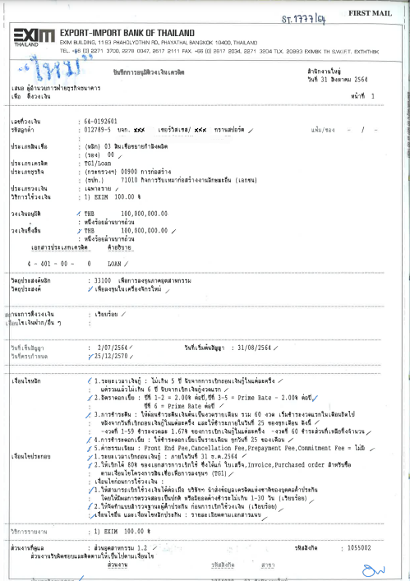

Facility Verify

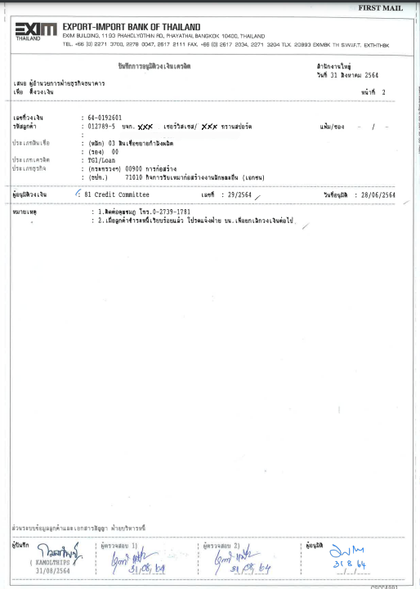

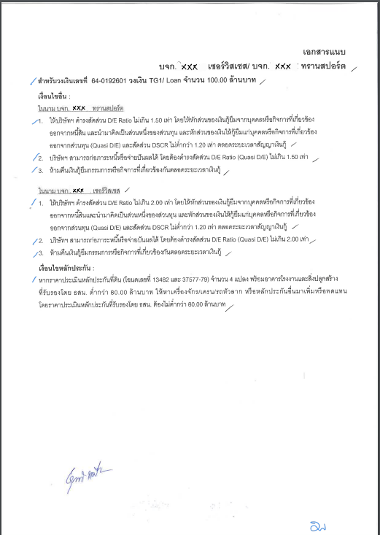

### Menu Modification

Not applicable

### Screen Layout and Data Sheet

Not Applicable

### Business Rule / Business Logic

* Daily / Adhoc / On-demand report
* Report Paramter criteria

| Paper Size | A4 |
| --- | --- |
| Reprinting Require | Yes |
| Searching Criteria | Customer ID (Main/Co-Borrower), Customer Name, Group ID, Group Name, Limit ID, Date, Date range |

### To-be Processing

The system will retrieve information from CBS Limits Facility function with details on:

* Limit Facility Details for both Customer and Customer Group shared limit information
* Description of products (Major/Minor) from business module static configuration set up screens
* Narrative Conditions needs to be retrieved from linked loan account that was created automatically during the time the limit facility was created
  + To link the loan account, CBS to use the following parameters:

1. Customer Code
2. Loan Account having same Major/Minor of the limit facility based on Group Limit ID
3. Loan Account status = New / Not Drawn

### File /API Layout and Data Sheet

### Report Layout and Data Sheet

| Screen/Report Field Name/Attributes (AS400) | Sample Data (AS400) | Source/Validations |
| --- | --- | --- |
| **Header** |  |  |
| Report Title | Credit Approval Record |  |
| Branch |  |  |
| System Date |  |  |
| Proposed to : Relationship Manager |  |  |
| Action : | Create Limt |  |
| Page |  |  |
| **Details** |  |  |
| Transaction Code | Create Limit |  |
| Limit ID | 640192601 |  |
| Loan Account Number |  |  |
| Group ID | Gxxxxx |  |
| Group Name |  |  |
| Customer ID - Main Borrower | 0051061 |  |
| Facility Verified Y/N |  | On BPM-approved, this will be N  On Limit approved, this will be Y |
| Customer Thai Name | Title+Customer Thai Name |  |
| Customer English Name |  |  |
| Customer ID - Co-Borrower | 0051072 |  |
| Customer Thai Name | Title+Customer Thai Name |  |
| Customer English Name |  |  |
| Major Credit Code + Minor Credit Code | 03 00 |  |
| Major/Minor Description | Capacity Expansion |  |
| Limit Description | Loan |  |
| Product Program | TG1 |  |
| Business Code: | 009000 การก่อสร้าง |  |
| BOT Business Code : | 71010 กิจการรับเหมาก่อสร้าง |  |
| Credit Type | Specific Project Limit |  |
| Currency | THB |  |
| Limit Amount | 100,000,000.00 |  |
| Source of Fund and Ratio | GSB 100% |  |
| Main Purpose Code | 33100 เพื่อการลงทุนภาคอุตสาหกรรม |  |
| Business Type | ซื้อเครื่องจักรใหม่ |  |
| Condition Deposit |  |  |
| Interest | 1st year = 3.50% 2nd-4th = Prime Rate + 1.0% |  |
| Fee | Fron end Fee = 1.0% Prepayment Fee = 2.0% Cancellation Fee = 0.5% Commitment Fee = 1.0% |  |
| Contract sign Date | 2/7/2021 |  |
| Effective Date | 31/8/2021 |  |
| Expiry Date | 25/12/2027 |  |
| Authorize No. | 29/2021 |  |
| Authorize Level | 81 Credit Committee |  |
| Authorize Date | 28/6/2021 |  |
| Customer Type  (retrive from CBS9 field Main Borrower) | Non-Resident |  |
| Country of Risk |  |  |
| Ratio of Risk |  |  |
| Business size  (retrive from CBS9 field Main Borrower) | L Large |  |
| Major Condition |  |  |
| Minor Condition |  |  |
| Condition Pre Approve |  |  |
| Condition Other |  |  |
| Hashtag | #BCG |  |
| Marketing Division  (retrive from CBS9 field Main Borrower) | ส่วนอุตสาหกรรม 1.2 |  |
| Operation Branch | Head Office |  |
| Credit Limit Remark | ติดต่อคุณชมภู่ โทร.0-2888-6000 |  |

### Additional Impacts

#### System Interface requirement /Integration

Not Applicable

#### Migration

Not Applicable

#### Fit/Gap Analysis Report

## Credit Advice Report - Increase Limit (Loan and O/D)

### Purpose

The Increase Limit (Loan and O/D) that belong to credit advice report is generated for these purposes:

* Send/notify the limit conditions details to operation team for drawdown.
* Others department can use this report for their purpose for example: legal department/marketing department can use this report as references for the completeness of create limit
* To be the reference document for histortical transaction that related limit

### Background

#### EXIM Current Business Pracitce (as is)

* As is report produced in AS/400
* Sample report in Support Sample Transaction and Case from Customer section

### Supported Sample Transaction and Case from Customer

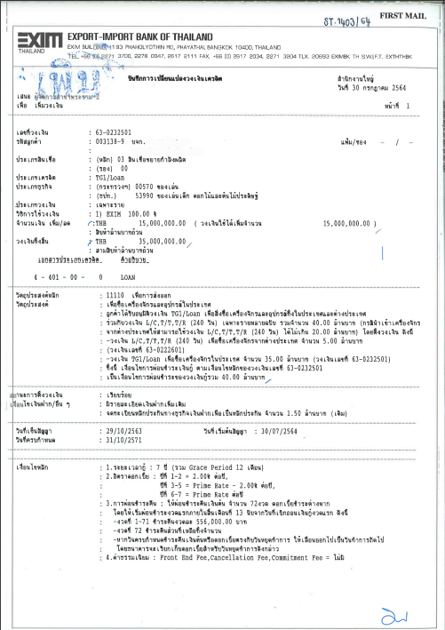

Facility Verify

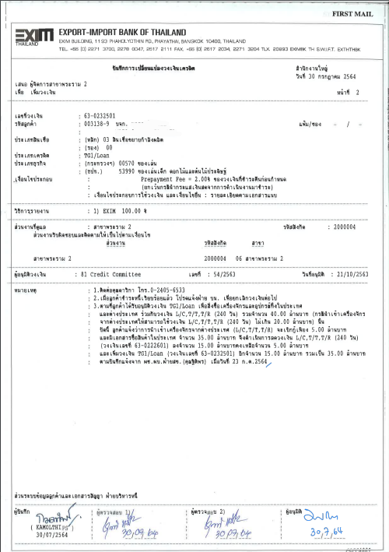

### Menu Modification

Not applicable

### Screen Layout and Data Sheet

Not Applicable

### Business Rule / Business Logic

* Daily / Adhoc / On-demand report
* Report Paramter criteria

| Paper Size | A4 |
| --- | --- |
| Reprinting Require | Yes |
| Searching Criteria | Customer ID (Main/Co-Borrower), Customer Name, Group ID, Group Name, Limit ID, Date, Date range |

### To-be Processing

As basis of generating the report, the system will retrieve information from CBS Limits Facility function with details on:

* Limit Facility Details where increase limit was performed
* Description of products (Major/Minor) from business module static configuration set up screens
* Narrative conditions for OD limit facility will be retrieved from Limit facility level
* Narrative Conditions needs to be retrieved from linked loan account
  + To link the loan account, CBS to use the following parameters:
* Check the Narrative entry where loan account number is stored
* Loan account at this level should be part of this report

Note:

1. Loan Amendment has to be performed (manually by designated team having access to loan amendment screen) to increase the loan amount on the basis of increased limit.
2. Once Loan Amendment has been approved at Loan Account level, Credit Advice report should reflect the updated loan amount, including updated narrative condition.

### File /API Layout and Data Sheet

### Report Layout and Data Sheet

| Screen/Report Field Name/Attributes (AS400) | Sample Data (AS400) | | Source/Validations | |
| --- | --- | --- | --- | --- |
| **Header** |  | |  | |
| Report Title | Credit Limit Management Record | |  | |
| Branch |  | |  | |
| System Date |  | |  | |
| Proposed to : Relationship Manager |  | |  | |
| Action : | Increase Limt | |  | |
| Page |  | |  | |
| **Details** |  | |  | |
| Transaction Code | Increase Limit | |  | |
| Limit ID | 650366601 | |  | |
| Loan Number | Loan Account number | |  |
| Customer ID | 0080008 | |  | |
| Customer Thai Name | Title+Customer Thai Name | |  | |
| Customer English Name |  | |  | |
| Facility Verified Y/N |  | On BPM-approved, this will be N  On Limit approved, this will be Y | | |
| Major Credit Code + Minor Credit Code | 05 00 | |  | |
| Major/Minor Description | Maritime | |  | |
| Limit Description | Loan | |  | |
| Product Program | BIZ | |  | |
| Business Code: | 01110 พาณิชย์นาวี | |  | |
| BOT Business Code : | 84060 การขนส่งทางน้ำระหว่างประเทศ | |  | |
| Credit Type | Specific Project Limit | |  | |
| Currency | THB | |  | |
| Old Limit Amount | 100,000,000.00 | |  | |
| Limit Amount Increase/Decrease | 30,000,000.00 | |  | |
| Total Limit Amount | 130,000,000.00 | |  | |
| Source of Fund and Ratio | EXIM 100% | |  | |
| Main Purpose Code | 21110 พาณิชย์นาวี/ขนส่งทางน้ำ | |  | |
| Business Type | Transport ship order | |  | |
| Condition Deposit |  | |  | |
| Interest | 1st year = 3.50% 2nd-4th = Prime Rate + 1.0% 5th = Prime Rate | |  | |
| Fee | Fron end Fee = 0.5% Prepayment Fee = 2.0% Cancellation Fee = 1.0% Commitment Fee = 1.0% | |  | |
| Contract sign Date | 9/6/2023 | |  | |
| Effective Date | 9/7/2023 | |  | |
| Expiry Date | 31/12/2028 | |  | |
| Authorize No. | 55/2023 | |  | |
| Authorize Level | 81 Credit Committee | |  | |
| Authorize Date | 1/2/2023 | |  | |
| Customer Type |  | |  | |
| Country of Risk |  | |  | |
| Ratio of Risk |  | |  | |
| Business size | M Medium | |  | |
| Major Condition |  | |  | |
| Minor Condition |  | |  | |
| Condition Pre Approve |  | |  | |
| Condition Other |  | |  | |
| Condition Modify |  | |  | |
| Hashtag | #CARBON#BCG | |  | |
| Marketing Division | ส่วนอุตสาหกรรม 5.2 | |  | |
| Operation Branch | Rama 2 Branch | |  | |
| Credit Limit Remark | ติดต่อคุณวิฑูรย์ โทร.0-2174-8000 | |  | |

Note : In case Group Limit show more details as follows :

Group ID, Group Name, Customer ID (Main/Co-Borrower), Customer Thai Name

(Main/Co-Borrower), Customer English Name (Main/Co-Borrower)

### Additional Impacts

#### System Interface requirement /Integration

Not Applicable

#### Migration

Not Applicable

#### Fit/Gap Analysis Report

## Credit Advice Report - Decrease Limit (Loan and O/D)

### Purpose

The Decrease Limit (Loan and O/D) that belong to credit advice report is generated for these purposes:

* Send/notify the limit conditions details to operation team for amendment / drawdown.
* Others department can use this report for their purpose for example: legal department/marketing department can use this report as references for the completeness of create limit
* To be the reference document for histortical transaction that related limit

### Background

#### EXIM Current Business Pracitce (as is)

* As is report produced in AS/400
* Sample report in Support Sample Transaction and Case from Customer section

### Supported Sample Transaction and Case from Customer

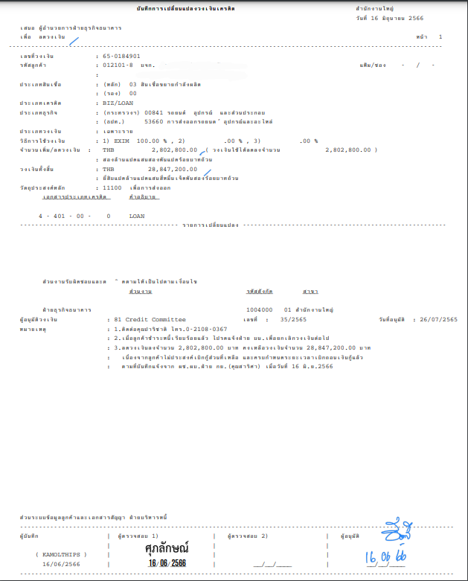

Facility Verify

### Menu Modification

Not applicable

### Screen Layout and Data Sheet

Not Applicable

### Business Rule / Business Logic

* Daily / Adhoc / On-demand report
* Report Paramter criteria

| Paper Size | A4 |
| --- | --- |
| Reprinting Require | Yes |
| Searching Criteria | Customer ID (Main/Co-Borrower), Customer Name, Group ID, Group Name, Limit ID, Date, Date range |

### To-be Processing

As basis of generating the report, the system will retrieve information from CBS Limits Facility function with details on:

* Limit Facility Details where decrease limit was performed
* Description of products (Major/Minor) from business module static configuration set up screens
* Narrative conditions for OD limit facility will be retrieved from Limit facility level
* Narrative Conditions needs to be retrieved from linked loan account Cr
  + To link the loan account, CBS to use the following parameters:
* Check the Narrative entry where loan account number is stored
* Loan account at this level should be part of this report

Note:

1. Loan Amendment has to be performed (manually by designated team having access to loan amendment screen) to decrease the loan amount on the basis of decreased limit.
2. Once Loan Amendment has been approved at Loan Account level, Credit Advice report should reflect the updated loan amount, including updated narrative condition.

### File /API Layout and Data Sheet

### Report Layout and Data Sheet

| Screen/Report Field Name/Attributes (AS400) | Sample Data (AS400) | | Source/Validations |
| --- | --- | --- | --- |
| **Header** |  | |  |
| Report Title | Credit Limit Management Record | |  |
| Branch |  | |  |
| System Date |  | |  |
| Proposed to : Relationship Manager |  | |  |
| Action : | Decrease Limt | |  |
| Page |  | |  |
| **Details** |  | |  |
| Transaction Code | Decrease Limit | |  |
| Limit ID | 650184901 | |  |
| Loan Account Number |  | |  |
| Facility Verified Y/N |  | On BPM-approved, this will be N  On Limit approved, this will be Y | |
| Customer ID | 0121018 | |  |
| Customer Thai Name | Title+Customer Thai Name | |  |
| Customer English Name |  | |  |
| Major Credit Code + Minor Credit Code | 04 00 | |  |
| Major/Minor Description | International Project | |  |
| Limit Description | Loan | |  |
| Product Program |  | |  |
| Business Code: | 01020 ไฟฟ้าและแสงสว่าง | |  |
| BOT Business Code : | 81000 การไฟฟ้า | |  |
| Credit Type | Specific Project Limit | |  |
| Currency | JPY | |  |
| Old Limit Amount | 1,200,000,000.00 | |  |
| Limit Amount Increase/Decrease | 100,000,000.00 | |  |
| Total Limit Amount | 1,100,000,000.00 | |  |
| Source of Fund and Ratio | EXIM 100% | |  |
| Main Purpose Code | 32130 โรงงานไฟฟ้าขนาดเล็กมาก (Very Small Power Producer | |  |
| Business Type | To buy shares | |  |
| Condition Deposit |  | |  |
| Interest | 1st year = 3.50% 2nd-4th = Prime Rate + 1.0% 5th-9th = Prime Rate | |  |
| Fee | Fron end Fee = 0.5% Prepayment Fee = 2.0% Cancellation Fee = 1.0% Commitment Fee = 1.0% | |  |
| Contract sign Date | 1/6/2017 | |  |
| Effective Date | 20/7/2017 | |  |
| Expiry Date | 31/10/2026 | |  |
| Authorize No. | 55/2017 | |  |
| Authorize Level | 81 Credit Committee | |  |
| Authorize Date | 1/2/2017 | |  |
| Customer Type | Non-Resident | |  |
| Country of Risk | JP Japan | |  |
| Ratio of Risk | 1.00 | |  |
| Business size | L Large | |  |
| Major Condition |  | |  |
| Minor Condition |  | |  |
| Condition Pre Approve |  | |  |
| Condition Other |  | |  |
| Condition Modify |  | |  |
| Hashtag | #CARBON#BCG | |  |
| Marketing Division | ส่วนอุตสาหกรรม 5.2 | |  |
| Operation Branch | Rama 2 Branch | |  |
| Credit Limit Remark | ติดต่อคุณวิฑูรย์ โทร.0-2174-8000 | |  |

Note : In case Group Limit show more details as follows :

Group ID, Group Name, Customer ID (Main/Co-Borrower), Customer Thai Name

(Main/Co-Borrower), Customer English Name (Main/Co-Borrower)

### Additional Impacts

#### System Interface requirement /Integration

Not Applicable

#### Migration

Not Applicable

#### Fit/Gap Analysis Report

## Credit Advice Report - Change Limit Conditions (Loan and O/D)

### Purpose

The Change Limit Conditions that belong to credit advice report is generated for these purposes:

* Send/notify the limit conditions details to operation team for drawdown.
* Others department can use this report for their purpose for example: legal department/marketing department can use this report as references for the completeness of create limit
* To be the reference document for histortical transaction that related limit

### Background

#### EXIM Current Business Pracitce (as is)

* As is report produced in AS/400
* Sample report in Support Sample Transaction and Case from Customer section

### Supported Sample Transaction and Case from Customer

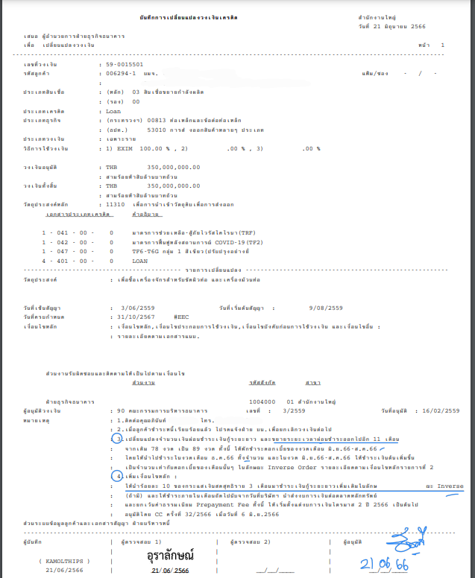

Facility Verify

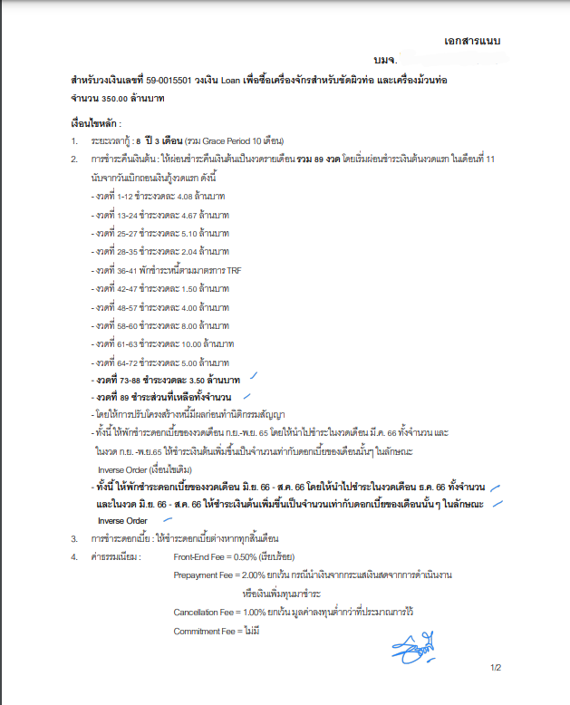

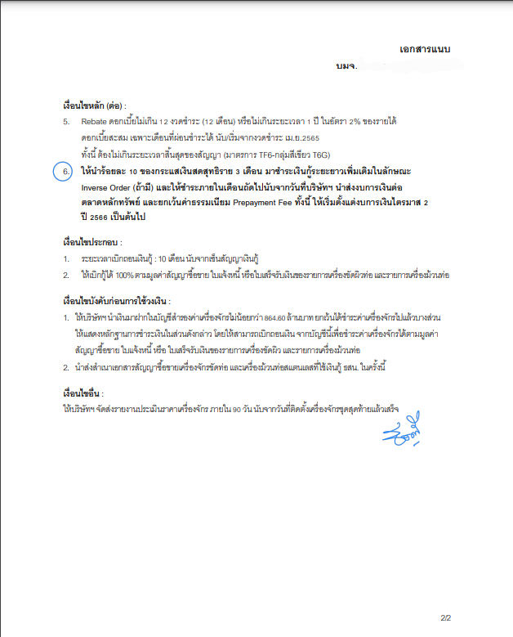

### Menu Modification

Not applicable

### Screen Layout and Data Sheet

Not Applicable

### Business Rule / Business Logic

* Daily / Adhoc / On-demand report
* Report Paramter criteria

| Paper Size | A4 |
| --- | --- |
| Reprinting Require | Yes |
| Searching Criteria | Customer ID (Main/Co-Borrower), Customer Name, Group ID, Group Name, Limit ID, Date, Date range |

### To-be Processing

As basis of generating the report, the system will retrieve information from CBS Limits Facility function with details on:

* Limit Facility Details where change condition was performed
* Description of products (Major/Minor) from business module static configuration set up screens
* Narrative conditions for OD limit facility will be retrieved from Limit facility level
* Narrative Conditions needs to be retrieved from linked loan account Cr
  + To link the loan account, CBS to use the following parameters:
* Check the Narrative entry where loan account number is stored
* Loan account at this level should be part of this report

Note:

1. Once Narrative conditions has been ticked mark Verify Y at Loan Account level, Credit Advice report should reflect the updated narrative condition.

### File /API Layout and Data Sheet

### Report Layout and Data Sheet

| Screen/Report Field Name/Attributes (AS400) | Sample Data (AS400) | Source/Validations |
| --- | --- | --- |
| **Header** |  |  |
| Report Title | Credit Limit Management Record |  |
| Branch |  |  |
| System Date |  |  |
| Proposed to : Relationship Manager |  |  |
| Action : | Change Condition |  |
| Page |  |  |
| **Details** |  |  |
| Transaction Code | Change Condition |  |
| Limit ID | 590015501 |  |
| Loan Account Number |  |  |
| Facility Verified Y/N |  | On BPM-approved, this will be N  On Limit approved, this will be Y |
| Customer ID | 0062941 |  |
| Customer Thai Name | Title+Customer Thai Name |  |
| Customer English Name |  |  |
| Major Credit Code + Minor Credit Code | 03 00 |  |
| Major/Minor Description | Capacity Expansion |  |
| Limit Description | Loan |  |
| Product Program |  |  |
| Business Code: | 00813 ท่อเหล็กและข้อต่อท่อเหล็ก |  |
| BOT Business Code : | 53010 การส่งออกสินค้าหลาย ๆ ประเภท |  |
| Credit Type | Specific Project Limit |  |
| Currency | THB |  |
| Limit Amount | 350,000,000.00 |  |
| Source of Fund and Ratio | EXIM 100% |  |
| Main Purpose Code | 11310 เพื่อการนำเข้าวัตถุดิบเพื่อการส่งออก |  |
| Business Type | เพื่อสั่งซื้อเครื่องจักร |  |
| Condition Deposit |  |  |
| Interest | 1st year = 3.50% 2nd-4th = Prime Rate + 1.0% 5th = Prime Rate |  |
| Fee | Fron end Fee = 0.5% Prepayment Fee = 2.0% Cancellation Fee = 1.0% Commitment Fee = 1.0% |  |
| Contract sign Date | 9/6/2023 |  |
| Effective Date | 9/7/2023 |  |
| Expiry Date | 31/12/2028 |  |
| Authorize No. | 55/2023 |  |
| Authorize Level | 81 Credit Committee |  |
| Authorize Date | 1/2/2023 |  |
| Customer Type |  |  |
| Country of Risk |  |  |
| Ratio of Risk |  |  |
| Business size | M Medium |  |
| Major Condition | ผ่อนชำระ 89 งวด ดังนี้  งวดที่ 1 - 12 …....  งวดที่ 13 - 24 …...  ….................  งวดที่ 73 - 88 ชำระงวดละ 3.50 ล้านบาท  งวดที่ 89 ชำระส่วนที่เหลือทั้งจำนวน |  |
| Minor Condition |  |  |
| Condition Pre Approve |  |  |
| Condition Other |  |  |
| Condition Modify | เปลี่ยนแปลงงวดการผ่อนชำระ งวดที่ 73-88 ชำระงวดละ 3.50 ล้านบาท |  |
| Hashtag | #CARBON#BCG |  |
| Marketing Division | ส่วนอุตสาหกรรม 5.2 |  |
| Operation Branch | Rama 2 Branch |  |
| Credit Limit Remark | ติดต่อคุณวิฑูรย์ โทร.0-2174-8000 |  |

Note : In case Group Limit show more details as follows :

Group ID, Group Name, Customer ID (Main/Co-Borrower), Customer Thai Name

(Main/Co-Borrower), Customer English Name (Main/Co-Borrower)

### Additional Impacts

#### System Interface requirement /Integration

Not Applicable

#### Migration

Not Applicable

#### Fit/Gap Analysis Report

## Credit Advice Report - Hold Limit (Loan and O/D)

### Purpose

The Hold Limit (Loan and O/D) that belong to credit advice report is generated for these purposes:

* Send/notify the limit conditions details to operation team for amendment / drawdown.
* Others department can use this report for their purpose for example: legal department can use this report as references for the completeness of create limit
* To be the reference document for histortical transaction that related limit

### Background

#### EXIM Current Business Pracitce (as is)

* As is report produced in AS/400
* Sample report in Support Sample Transaction and Case from Customer section

### Supported Sample Transaction and Case from Customer

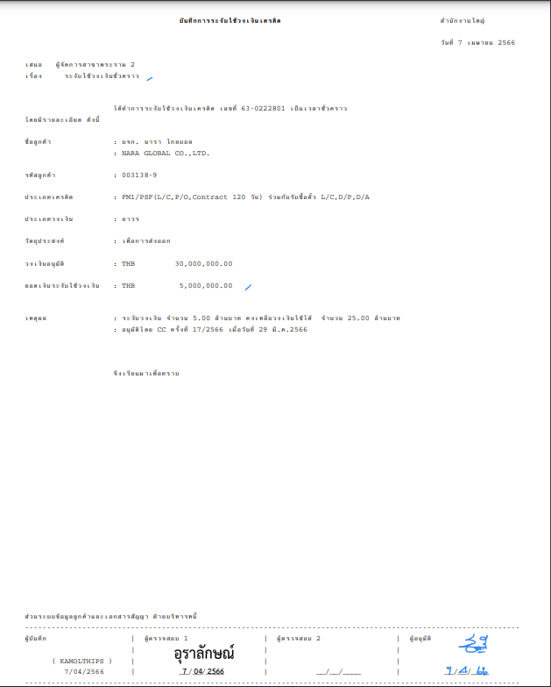

Facility Verify

### Menu Modification

Not applicable

### Screen Layout and Data Sheet

Not Applicable

### Business Rule / Business Logic

* Daily / Adhoc / On-demand report
* Report Paramter criteria

| Paper Size | A4 |
| --- | --- |
| Reprinting Require | Yes |
| Searching Criteria | Customer ID (Main/Co-Borrower), Customer Name, Group ID, Group Name, Limit ID, Date, Date range |

### To-be Processing

As basis of generating the report, the system will retrieve information from CBS Limits Facility function with details on:

* Limit Facility Details where hold limit (where hold indicator marked as Y) was performed
* Description of products (Major/Minor) from business module static configuration set up screens
* Narrative conditions for OD limit facility will be retrieved from Limit facility level
* Narrative Conditions needs to be retrieved from linked loan account Cr
  + To link the loan account, CBS to use the following parameters:
* Check the Narrative entry where loan account number is stored
* Loan account at this level should be part of this report

Note:

1. Loan Amendment has to be performed (manually by designated team having access to loan amendment screen) to decrease or update the loan amount on the basis of hold limit.
2. Once Loan Amendment has been approved at Loan Account level, Credit Advice report should reflect the updated loan amount, including updated narrative condition.

### File /API Layout and Data Sheet

### Report Layout and Data Sheet

| Screen/Report Field Name/Attributes (AS400) | Sample Data (AS400) | Source/Validations |
| --- | --- | --- |
| **Header** |  |  |
| Report Title | Credit Limit Management Record |  |
| Branch |  |  |
| System Date |  |  |
| Proposed to : Relationship Manager |  |  |
| Action : | Hold Limit |  |
| Page |  |  |
| **Details** |  |  |
| Transaction Code | Hold Limit |  |
| Facility Verified Y/N |  | On BPM-approved, this will be N  On Limit approved, this will be Y |
| Limit ID | 650444401 |  |
| Loan Account Number |  |  |
| Customer ID | 0080029 |  |
| Customer Thai Name | Title+Customer Thai Name |  |
| Customer English Name |  |  |
| Major Credit Code + Minor Credit Code | 06 00 |  |
| Major/Minor Description | Overdraft |  |
| Limit Description | O/D |  |
| Product Program |  |  |
| Business Code: | 01020 ไฟฟ้าและแสงสว่าง |  |
| BOT Business Code : | 81000 การไฟฟ้า |  |
| Credit Type | Permanent Limit |  |
| Currency | THB |  |
| Limit Amount | 3,000,000.00 |  |
| Hold Limit Amount | 1,000,000.00 |  |
| Source of Fund and Ratio | EXIM 100% |  |
| Main Purpose Code | 32130 โรงงานไฟฟ้าขนาดเล็กมาก (Very Small Power Producer |  |
| Business Type | เพื่อใช้หมุนเวียนในธุรกิจ |  |
| Contract sign Date | 1/6/2023 |  |
| Effective Date | 7/7/2023 |  |
| Expiry Date | 31/12/9999 |  |
| Authorize No. | 65/2023 |  |
| Authorize Level | 81 Credit Committee |  |
| Authorize Date | 1/7/2023 |  |
| Customer Type |  |  |
| Country of Risk |  |  |
| Ratio of Risk |  |  |
| Business size | L Large |  |
| Condition Modify |  |  |
| Marketing Division | ส่วนอุตสาหกรรม 5.2 |  |
| Operation Branch | Rama 2 Branch |  |
| Credit Limit Remark | ติดต่อคุณไพรัตน์ โทร.0-2174-6000 |  |

Note : In case Group Limit show more details as follows :

Group ID, Group Name, Customer ID (Main/Co-Borrower), Customer Thai Name

(Main/Co-Borrower), Customer English Name (Main/Co-Borrower)

### Additional Impacts

#### System Interface requirement /Integration

Not Applicable

#### Migration

Not Applicable

#### Fit/Gap Analysis Report

## Credit Advice Report - Unhold Limit (Loan and O/D)

### Purpose

The Unhold Limit (Loan and O/D) that belong to credit advice report is generated for these purposes:

* Send/notify the limit conditions details to operation team for amendment / drawdown.
* Others department can use this report for their purpose for example: legal department can use this report as references for the completeness of create limit
* To be the reference document for histortical transaction that related limit

### Background

#### EXIM Current Business Pracitce (as is)

* As is report produced in AS/400
* Sample report in Support Sample Transaction and Case from Customer section

### Supported Sample Transaction and Case from Customer

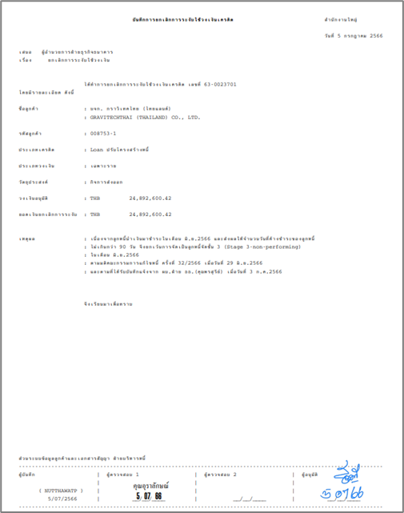

Facility Verify

### Menu Modification

Not applicable

### Screen Layout and Data Sheet

Not Applicable

### Business Rule / Business Logic

* Daily / Adhoc / On-demand report
* Report Paramter criteria

| Paper Size | A4 |
| --- | --- |
| Reprinting Require | Yes |
| Searching Criteria | Customer ID (Main/Co-Borrower), Customer Name, Group ID, Group Name, Limit ID, Date, Date range |

### To-be Processing

As basis of generating the report, the system will retrieve information from CBS Limits Facility function with details on:

* Limit Facility Details where unhold limit was performed
* Description of products (Major/Minor) from business module static configuration set up screens
* Narrative conditions for OD limit facility will be retrieved from Limit facility level
* Narrative Conditions needs to be retrieved from linked loan account Cr
  + To link the loan account, CBS to use the following parameters:
* Check the Narrative entry where loan account number is stored
* Loan account at this level should be part of this report

Note:

1. Loan Amendment has to be performed (manually by designated team having access to loan amendment screen) to update the loan amount on the basis of unhold limit.
2. Once Loan Amendment has been approved at Loan Account level, Credit Advice report should reflect the updated loan amount, including updated narrative condition.

### File /API Layout and Data Sheet

### Report Layout and Data Sheet

| Screen/Report Field Name/Attributes (AS400) | Sample Data (AS400) | | Source/Validations |
| --- | --- | --- | --- |
| **Header** |  | |  | |
| Report Title | Credit Limit Management Record | |  | |
| Branch |  | |  | |
| System Date |  | |  | |
| Proposed to : Relationship Manager |  | |  | |
| Action : | Unhold Limit | |  | |
| Page |  | |  | |
| **Details** |  | |  | |
| Transaction Code | Unhold Limit | |  |
| Facility Verified Y/N |  | On BPM-approved, this will be N  On Limit approved, this will be Y | | |
| Limit ID | 660444301 | |  |
| Loan Account Number |  | |  |
| Customer ID | 0080029 | |  |
| Customer Thai Name | Title+Customer Thai Name | |  |
| Customer English Name |  | |  |
| Major Credit Code + Minor Credit Code | 04 00 | |  |
| Major/Minor Description | Loan | |  |
| Limit Description | TG1 | |  |
| Product Program |  | |  |
| Business Code: | 01020 ไฟฟ้าและแสงสว่าง | |  |
| BOT Business Code : | 81000 การไฟฟ้า | |  |
| Credit Type | Specific Project Limit | |  |
| Currency | USD | |  |
| Limit Amount | 2,000,000.00 | |  |
| Unhold Limit Amount | 500,000.00 | | CBS Report to retrieve latest activity event of unhold |
| Source of Fund and Ratio | EXIM 100% | |  |
| Main Purpose Code | 32130 โรงงานไฟฟ้าขนาดเล็กมาก (Very Small Power Producer | |  |
| Business Type | เพื่อลงทุนในโครงการเขื่อนในประเทศลาว | |  |
| Contract sign Date | 1/6/2023 | |  |
| Effective Date | 7/7/2023 | |  |
| Expiry Date | 31/09/2028 | |  |
| Authorize No. | 65/2023 | |  |
| Authorize Level | 81 Credit Committee | |  |
| Authorize Date | 1/7/2023 | |  |
| Customer Type | Non-Resident | |  |
| Country of Risk | LA LAO | |  |
| Ratio of Risk | 1.00 | |  |
| Business size | M Medium | |  |
| Condition Modify |  | |  |
| Hashtag | #CARBON#BCG | |  |
| Marketing Division | ส่วนอุตสาหกรรม 5.2 | |  |
| Operation Branch | Rama II Branch | |  |
| Credit Limit Remark | ติดต่อคุณไพรัตน์ โทร.0-2174-6000 | |  |

Note : In case Group Limit show more details as follows :

Group ID, Group Name, Customer ID (Main/Co-Borrower), Customer Thai Name

(Main/Co-Borrower), Customer English Name (Main/Co-Borrower)

### Additional Impacts

#### System Interface requirement /Integration

Not Applicable

#### Migration

Not Applicable

#### 1.8.9.2.3 Fit/Gap Analysis Report

## Credit Advice Report - Cancel Limit (Loan and O/D)

The purpose of this document is to provide the solution through functional specification resulting from the TOR and Gaps identified during the Product Workshop activity held April 26 to May 16, 2023 at EXIM Bank of Thailand.

### Purpose

The Cancel Limit (Loan and O/D) that belong to credit advice report is generated for these purposes:

* Send/notify the limit conditions details to operation team for drawdown.
* Others department can use this report for their purpose for example: legal department can use this report as references for the completeness of create limit
* To be the reference document for histortical transaction that related limit

### Background

#### EXIM Current Business Pracitce (as is)

* As is report produced in AS/400
* Sample report in Support Sample Transaction and Case from Customer section

### Supported Sample Transaction and Case from Customer

#### For Loan

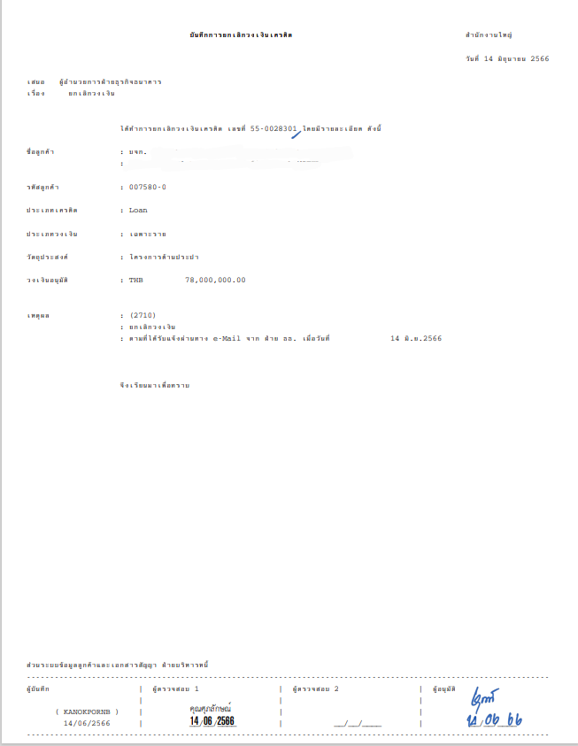

Facility Verify

#### For OD

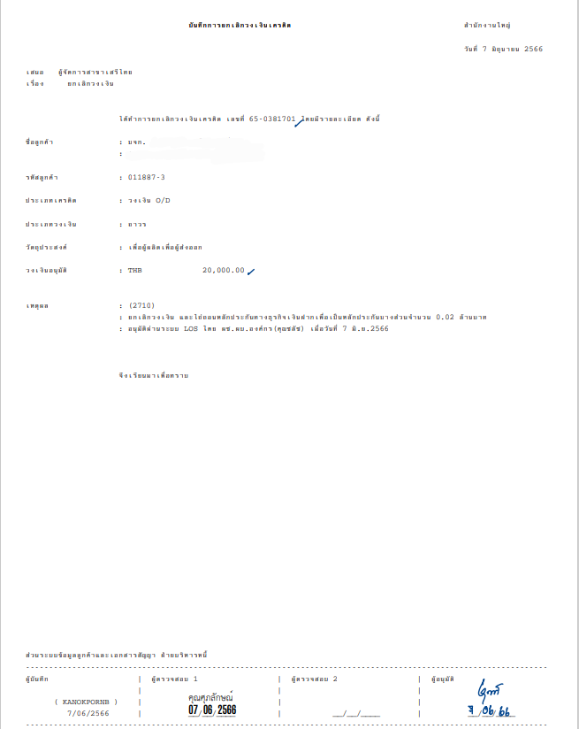

### Menu Modification

Not applicable

### Screen Layout and Data Sheet

Not Applicable

### Business Rule / Business Logic

* Daily / Adhoc / On-demand report
* Report Paramter criteria

| Paper Size | A4 |
| --- | --- |
| Reprinting Require | Yes |
| Searching Criteria | Customer ID (Main/Co-Borrower), Customer Name, Group ID, Group Name, Limit ID, Date, Date range |

### To-be Processing

As basis of generating the report, the system will retrieve information from CBS Limits Facility function with details on:

* Limit Facility Details where cancel limit was performed
* Description of products (Major/Minor) from business module static configuration set up screens
* Narrative conditions for OD limit facility will be retrieved from Limit facility level
* Narrative Conditions needs to be retrieved from linked loan account Cr
  + To link the loan account, CBS to use the following parameters:
* Check the Narrative entry where loan account number is stored
* Loan account at this level should be part of this report

Note:

1. Loan Cancellation has to be performed (manually by designated team having access to loan amendment screen) to update the loan status.
2. Once Loan Cancellation has been approved at Loan Account level, Credit Advice report should reflect the cancelled loan.

### File /API Layout and Data Sheet

### Report Layout and Data Sheet

| Screen/Report Field Name/Attributes (AS400) | Sample Data (AS400) | Source/Validations |
| --- | --- | --- |
| **Header** |  |  |
| Report Title | Credit Limit Management Record |  |
| Branch |  |  |
| System Date |  |  |
| Proposed to : Relationship Manager |  |  |
| Action : | Cancel Limit |  |
| Page |  |  |
| **Details** |  |  |
| Transaction Code | Cancel Limit |  |
| Facility Verified Y/N |  | On BPM-approved, this will be N  On Limit approved, this will be Y |
| Limit ID | 550028301 |  |
| Loan Account Number |  |  |
| Customer ID | 0075800 |  |
| Customer Thai Name | Title+Customer Thai Name |  |
| Customer English Name |  |  |
| "Major Credit Code + Minor Credit Code" | 04 00 |  |
| Major/Minor Description | Loan |  |
|  |  |  |
| Limit Description | TG1 |  |
| Product Program |  |  |
| Business Code: | 01020 ไฟฟ้าและแสงสว่าง |  |
| BOT Business Code : | 81000 การไฟฟ้า |  |
| Credit Type | Specific Project Limit |  |
| Currency | USD |  |
| Limit Amount | 5,000,000.00 |  |
| Source of Fund and Ratio | EXIM 100% |  |
| Main Purpose Code | 32130 โรงงานไฟฟ้าขนาดเล็กมาก (Very Small Power Producer |  |
| Business Type | Construction |  |
| Contract sign Date | 1/6/2023 |  |
| Effective Date | 7/7/2023 |  |
| Expiry Date | 31/09/2028 |  |
| Authorize No. | 65/2023 |  |
| Authorize Level | 81 Credit Committee |  |
| Authorize Date | 1/7/2023 |  |
| Customer Type | Non-Resident |  |
| Country of Risk | MY Myanma |  |
| Ratio of Risk | 1.00 |  |
| Business size | M Medium |  |
| Condition Modify |  |  |
| Hashtag | #CARBON#BCG |  |
| Marketing Division | ส่วนอุตสาหกรรม 5.2 |  |
| Operation Branch | Rama II Branch |  |
| Credit Limit Remark | ติดต่อคุณไพรัตน์ โทร.0-2111-6000 |  |

Note : In case Group Limit show more details as follows :

Group ID, Group Name, Customer ID (Main/Co-Borrower), Customer Thai Name

(Main/Co-Borrower), Customer English Name (Main/Co-Borrower)

### Additional Impacts

#### System Interface requirement /Integration

Not Applicable

#### Migration

Not Applicable

#### 1.8.9.2.3 Fit/Gap Analysis Report

## Daily Report

### Purpose

This report is generated for displaying the daily limit movement which include create, increase, decrease, cancel, hold, unhold, transfer limit, and change limit conditions which illustrate all the data such as Data Entry, Verify 1, Verify 2, Approved, and Cancel as the Lists report.

The maker will proceed the verification of the limit movement in daily which will include the approved limit, credit type, credit type code, limit amount, credit limit supervisor, and service branch to be able generate the report with the correctness.

### Background

#### EXIM Current Business Pracitce (as is)

* As is report produced in AS/400
* Sample report in Support Sample Transaction and Case from Customer section

### Supported Sample Transaction and Case from Customer

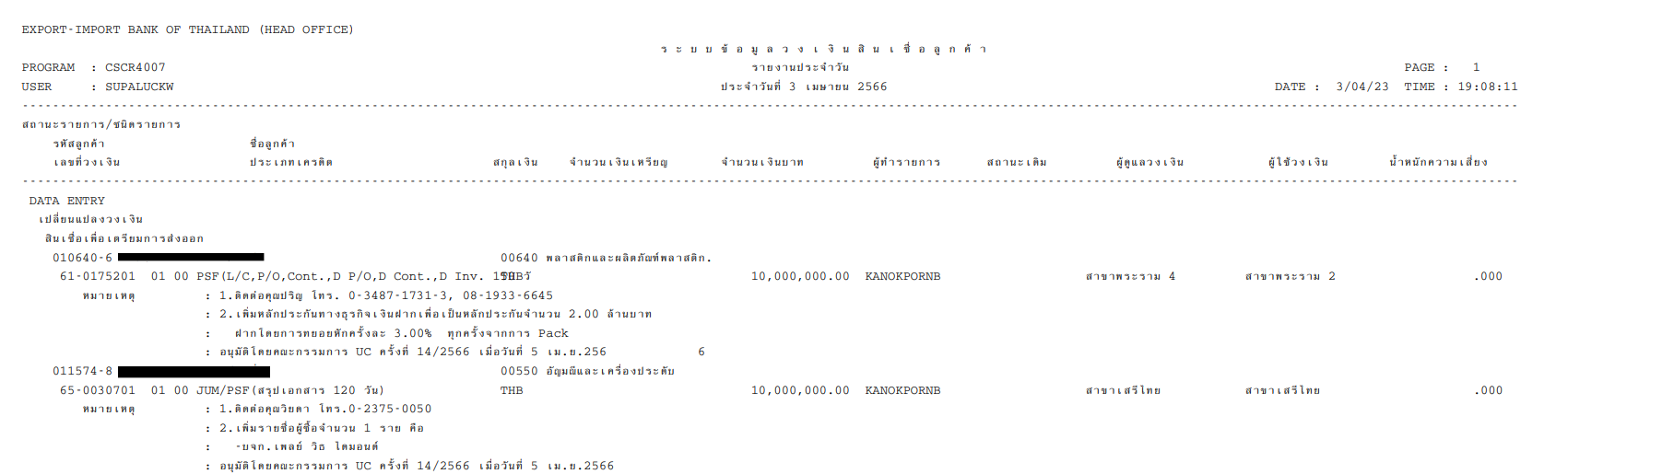



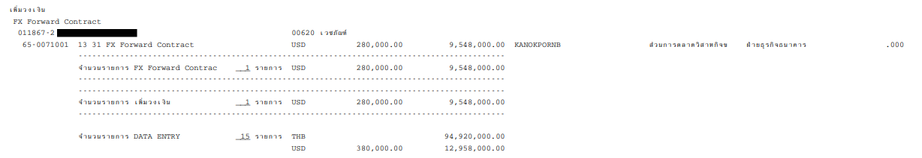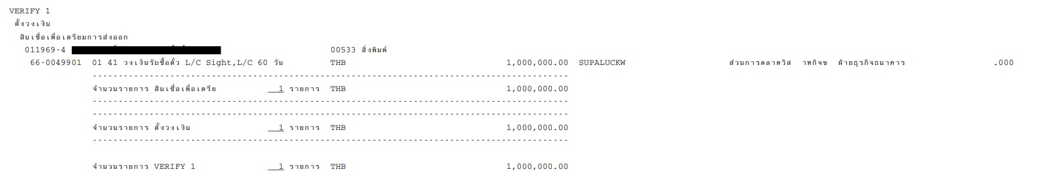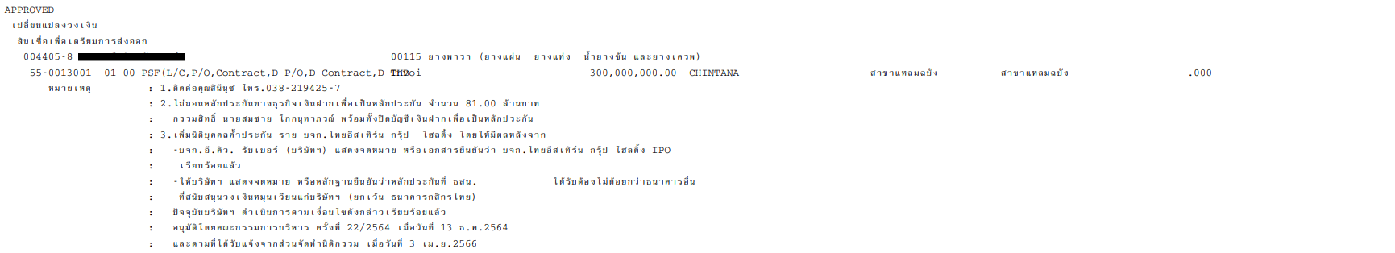







### Menu Modification

Not applicable

### Screen Layout and Data Sheet

Not Applicable

### Business Rule / Business Logic

| Paper Size | A4 |
| --- | --- |
| Reprinting Require | Yes |
| Searching Criteria | Period of Time (Daily) |

### To-be Processing

The system will retrieve information from CBS Limits Facility function with details on:

* Transaction Code where create, increase, decrease, cancel, hold, unhold and change limit condition was performed for the day
* Show all limit transactions in data entry, approve 1 in BPM (Limit Facility, Loan account), approve 2 in Limit Facility and Loan account
* Description of products (Major/Minor) from business module static configuration set up screens
* Narrative Conditions of the limit facility
* Add sum total of each limit facility record by transaction code? Or limit facility?
* เพิ่มการ sum ยอดรวมของ แต่ละรายการและวงเงิน
* แนบตัวอย่างรายงาน

### File /API Layout and Data Sheet

### Report Layout and Data Sheet

| Screen/Report Field Name/Attributes | Sample Data | Source/Validations |
| --- | --- | --- |
| Header |  |  |
| Title | Daily Report |  |
| Date | 3 April 2023 |  |
| Printed Page | 1 |  |
| Printed Date | 3/04/23 |  |
| Printed Time | 19:08:11 |  |
| Program | CSCR4007 |  |
| User (Retrive Report) | SUPALUCKW |  |
| Details |  |  |
| Type of Record | Data Entry, Verify 1, Verify 2, Approved, Cancel |  |
| Transaction Code | Create, Increase, Decrease, Hold, Unhold, Cancellation, Change Conditions. |  |
| Customer ID | 0106406 |  |
| Thai Title | หจก. |  |
| Customer Thai Name |  |  |
| Major Credit Code | 03 |  |
| Minor Credit Code | 00 |  |
| Major/Minor Description | สินเชื่อขยายกำลังการผลิต |  |
| Limit ID | 610175201 |  |
| Limit Description | Loan |  |
| Product Program | BIZ |  |
| Business Code | 00642 |  |
| Business Description | ผลิตภัณฑ์พลาสติกและพลาสติก |  |
| Currency | THB, USD |  |
| Foreign Currency Amount | 1,000,000.00 |  |
| Amount BAHT | 35,000,000.00 |  |
| Record Status |  |  |
| Overall Total Amount |  | sum total group by limit by limit facility |
| User (Maker) | KANOKPORNB |  |
| Marketing Department | Rama IV Branch |  |
| Operation Department | Head Office |  |
| Risk Weight |  |  |
| Credit Limit Remark |  |  |

### Additional Impacts

#### System Interface requirement /Integration

Not Applicable

#### Migration

Not Applicable

#### Fit/Gap Analysis Report

## Monthly Report

### Purpose

This report is generated for displaying the monthly limit movement which include create, increase, decrease, cancel, hold, unhold, transfer limit, and change limit conditions which illustrate all the data such as Data Entry, Verify 1, Verify 2, Approved, and Cancel as the Lists report

The maker will proceed the verification of the limit movement in monthly which will include the approved limit, credit type, credit type code, limit amount, credit limit supervisor, and service branch to be able generate the report with the correctness.

.

### Background

#### EXIM Current Business Pracitce (as is)

* As is report produced in AS/400
* Sample report in Support Sample Transaction and Case from Customer section

### Supported Sample Transaction and Case from Customer

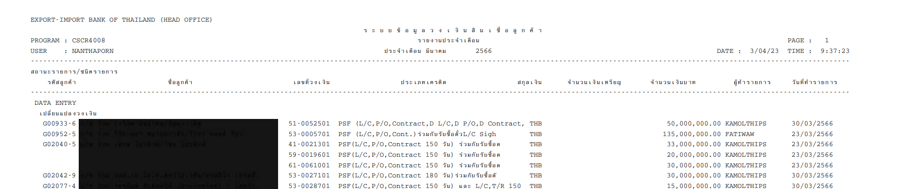

### Menu Modification

Not applicable

### Screen Layout and Data Sheet

Not Applicable

### Business Rule / Business Logic

| Paper Size | A4 |
| --- | --- |
| Reprinting Require | Yes |
| Searching Criteria | Period of Time (Monthly) |

### To-be Processing –

The system will retrieve information from CBS Limits Facility function with details on:

* Transaction code where create, increase, decrease, cancel, hold, unhold and change limit condition was performed for the month
* Show all limit transactions in data entry, approve 1 in BPM (Limit Facility, Loan account), approve 2 in Limit Facility and Loan account
* Description of products (Major/Minor) from business module static configuration set up screens
* Narrative Conditions of the limit facility
* เพิ่มการ sum ยอดรวมของ แต่ละรายการและวงเงิน

แนบตัวอย่างรายงาน

### File /API Layout and Data Sheet

### Report Layout and Data Sheet

| Screen/Report Field Name/Attributes | Sample Data | Source/Validations |
| --- | --- | --- |
| Header |  |  |
| Title | Monthly Report |  |
| Month | March 2023 |  |
| Printed Page | 1 |  |
| Printed Date | 3/04/23 |  |
| Printed Time | 19:08:11 |  |
| Program | CSCR4008 |  |
| User (Retrive Report) | SUPALUCKW |  |
| Details |  |  |
| Type of Record | Data Entry, Verify 1, Verify 2, Approved |  |
| Transaction Code | Create, Increase, Decrease, Hold, Unhold, Cancellation, Change Conditions. |  |
| Customer ID | 0106406 |  |
| Thai Title | หจก. |  |
| Customer Thai Name |  |  |
| Major Credit Code | 03 |  |
| Minor Credit Code | 00 |  |
| Major/Minor Description | สินเชื่อขยายกำลังการผลิต |  |
| Limit ID | 610175201 |  |
| Limit Description | Loan |  |
| Product Program | BIZ |  |
| Currency | THB, USD |  |
| Amount Limit | 1,000,000.00 |  |
| Amount Limit (THB) | 35,000,000.00 |  |
| User (Maker) | KAMOLTHIPS |  |
| Date of Performed | 3/04/2023 |  |

### Additional Impacts

#### System Interface requirement /Integration

Not Applicable

#### Migration

Not Applicable

#### Fit/Gap Analysis Report

## Approval credit limit report

### Purpose

After the credit limit have verified, the approval credit limit report will now be generated at this stage. The report is generate for summarize the approved limit for customer in each month by gathering the approval from the approver such as approve within the authorization, credit committee, re-structure loan ,and so on. The report can generate both PDF file and Excel file. In addtion for the excel file, the report be able to illustrate as type of old/new customer, limit ID, etc.

### Background

#### EXIM Current Business Pracitce (as is)

* As is report produced in AS/400
* Sample report in Support Sample Transaction and Case from Customer section
* The system will capture transaction code “Create Limit” and “Increase Limit” to this report
* After the credit limit have verified (verify 1) , or verify and approval (after sign contract) in each month, credit limit report will now be generated at this stage.

### Supported Sample Transaction and Case from Customer

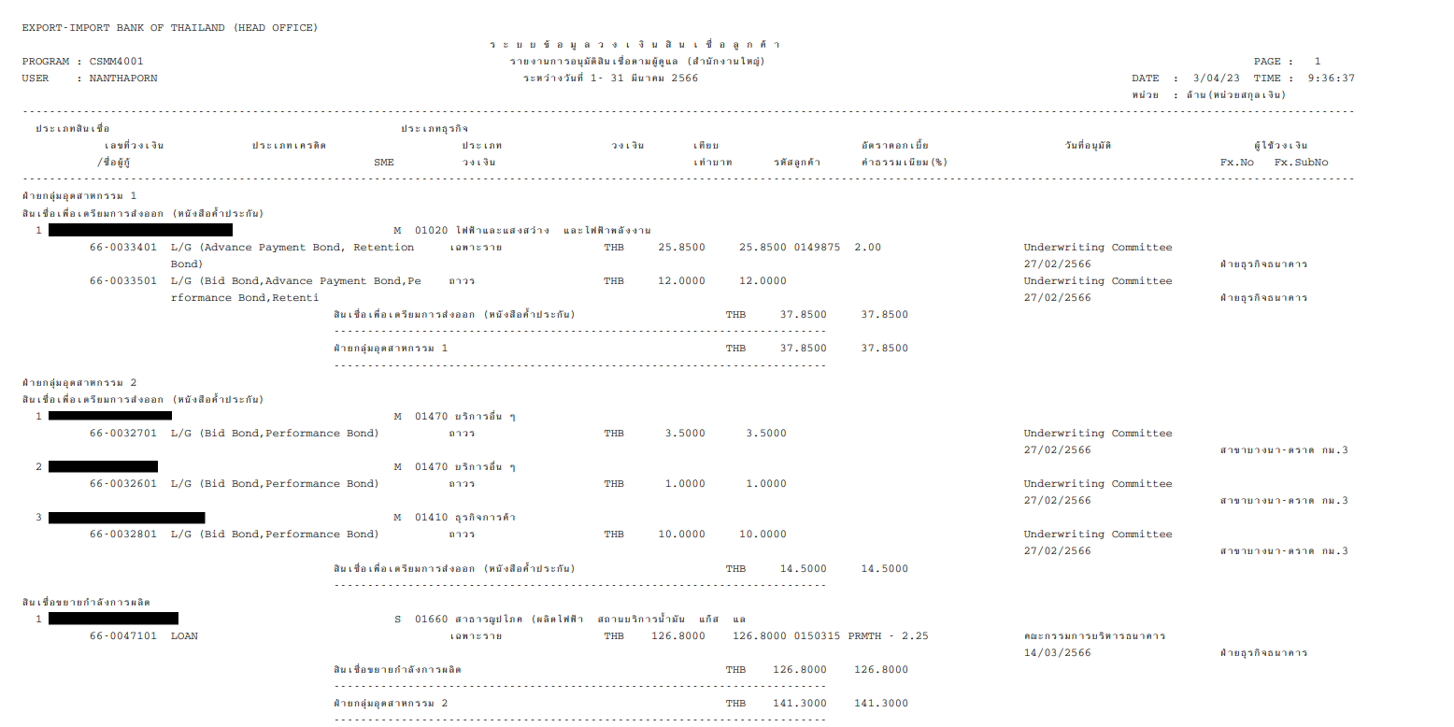

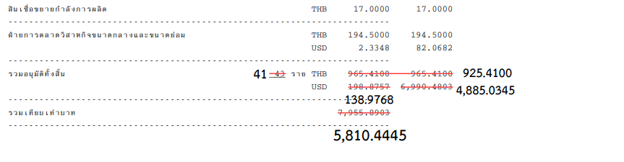

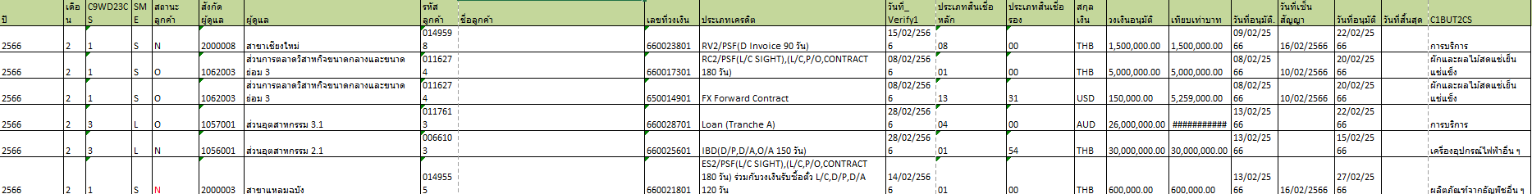

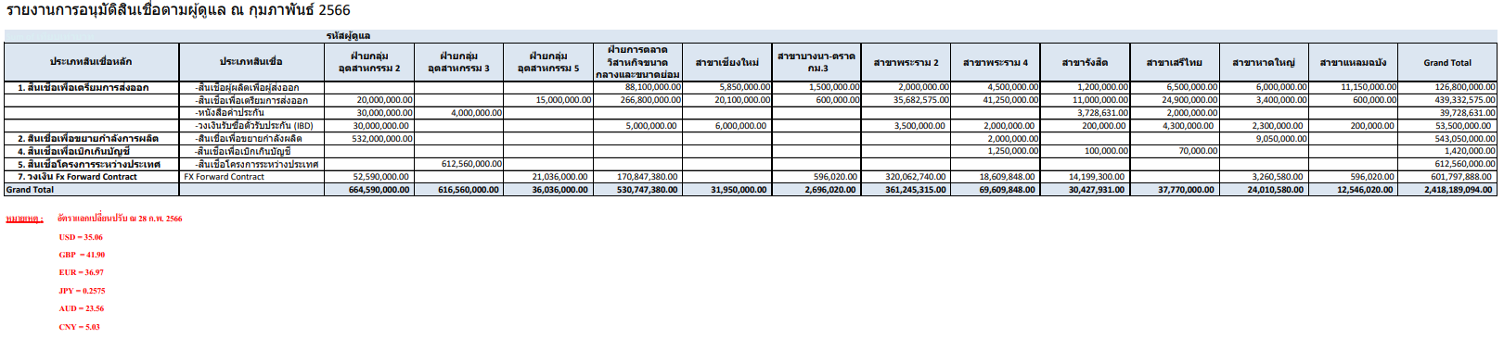

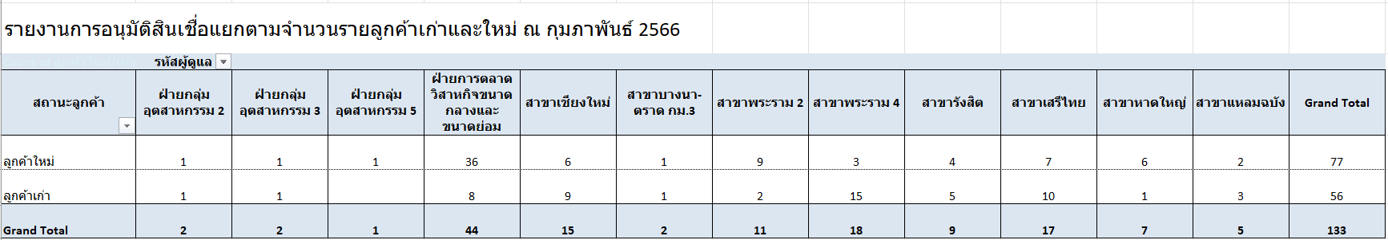

### Menu Modification

Not applicable

### Screen Layout and Data Sheet

Not Applicable

### Business Rule / Business Logic

|  |  |
| --- | --- |
|  |  |
|  |  |

The system will retrieve information from CBS Limits Facility function with details on:

* Limit information that will summarize the approved limit for customer performed for the month
* The system will capture transaction code “Create Limit” and “Increase Limit” to this report
* For the transaction increase limit will show the amount of additional amount
* Show all limit transactions in approve 1 in BPM (Limit Facility, Loan account), approve 2 in Limit Facility and Loan account
* Description of products (Major/Minor) from business module static configuration set up screens
* Add the sum total of limit for each loan type, Marketing Code, Branch
* เพิ่มการ sum ยอดรวมวงเงินของ แต่ละประเภทสินเชื่อ, Marketing Code, Branch
* แนบตัวอย่างรายงาน

### To-be Processing

|  |  |
| --- | --- |
|  |  |
|  |  |

Report logic process for increase transaction have 2 conditions to generate report after approved at BPM level (Approved at BPM level means, limit record has been created in CBS but limit verify flag is still set to N - No):

1. If LOS send “Project Code”, the report can be generated at limit facility level and the report must show the added amount

This will be considered as all limit facilities where created date is within the specified report criteria Month.

Example:

Loan report generate with criteria: August 2023

Limit Facility CLIDXX0 CEL approved and created in CBS July 2023

Limit Facility CLIDXX1 CEL approved and created in CBS August 2023

Limit Facility CLIDXX2 MTL approved and created in CBS August 2023

Approval Credit Limit report will include CLIDXX1 & CLIDXX2 for August 2023 report

1. If LOS send “Project Code and Loan account ID”, the report can generate at loan account level and at this stage, the report will include the amount that have added

This will be considered as all limit facilities where created date is within the specified report criteria Month + corresponding loan account having the same major/minor code of the limit facility code.

### File /API Layout and Data Sheet

### Report Layout and Data Sheet

| Screen/Report Field Name/Attributes | Sample Data | Source/Validations |
| --- | --- | --- |
| Header |  |  |
| Title | Approval Credit Limit Classified By User Report |  |
| Period of Time | 1-31 March 2023 |  |
| Printed Page | 1 |  |
| Printed Date | 3/04/23 |  |
| Printed Time | 19:08:11 |  |
| Program | CSMM4001 |  |
| User (Retrive Report) | SUPALUCKW |  |
| Details |  |  |
| Year | 2023 |  |
| Month | 3 |  |
| Marketing Segment Code | 1056001 |  |
| Marketing Segment | ส่วนอุตสาหกรรม 2.1 |  |
| Transaction Code | Create, Increase. |  |
| Status | New, Old |  |
| Business Size Code | 1 |  |
| Business Size | S small |  |
| Customer ID | 0106406 |  |
| Thai Title | บจก. |  |
| Customer Thai Name |  |  |
| Major Credit Code | 03 |  |
| Minor Credit Code | 00 |  |
| Major/Minor Description | สินเชื่อขยายกำลังการผลิต |  |
| Limit ID | 610175201 |  |
| Limit Description | Loan |  |
| Product Program | BIZ |  |
| Credit Type | Specific Project Limit |  |
| Currency | THB, USD |  |
| Amount Limit | 1,000,000.00 |  |
| Amount Limit (THB) | 35,000,000.00 |  |
| Authorize No. | 49/2023 |  |
| Authorize Level | 84 Underwriting Committee |  |
| Authorize Date | 20/03/2023 |  |
| Effective Date | 28/03/2023 |  |
| Contract Sign Date | 30/11/66 |  |
| Operation Branch | Rama IV Branch |  |
| Business Code | 00642 |  |
| Business Description | ผลิตภัณฑ์พลาสติกและพลาสติก |  |
| Hashtag | #EEC |  |

### Additional Impacts

#### System Interface requirement /Integration

Not Applicable

#### Migration

Not Applicable

#### Fit/Gap Analysis Report

## Sign contract report

### Purpose

This report is generated for summarize the customer limit that sign contract completely in each month, also summarzie since beginning of the year untill the present month which will classify into department and branches.

After the credit limit have approved and customer signed contract, the sign contract report will now be generated at this stage to notify the user that the limit is available and to keep the track on marketing performance.

### Background

#### EXIM Current Business Pracitce (as is)

* As is report produced in AS/400
* Sample report in Support Sample Transaction and Case from Customer section
* The system will capture transaction code “Create Limit” and “Increase Limit” to this report
* After the credit limit have approved and customer signed contract in each month, the sign contract report will now be generated at this stage

### Supported Sample Transaction and Case from Customer

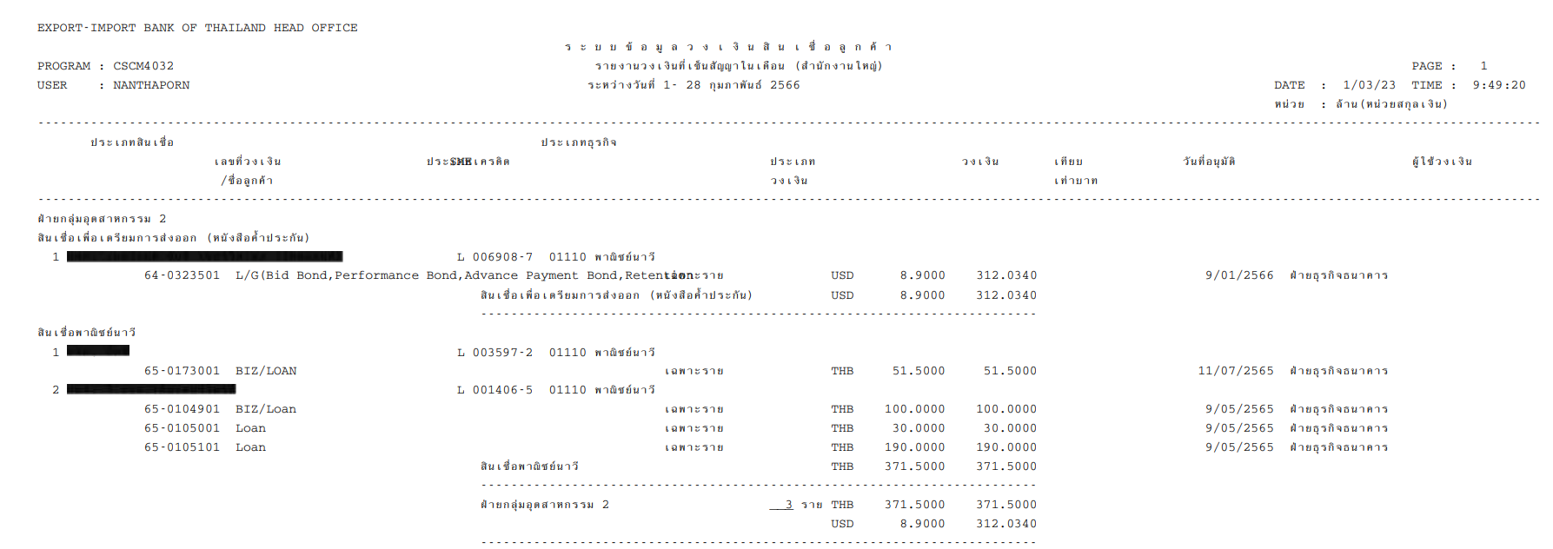

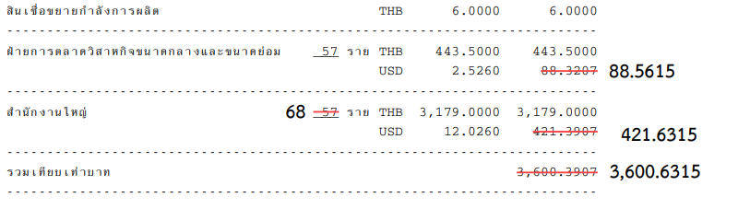

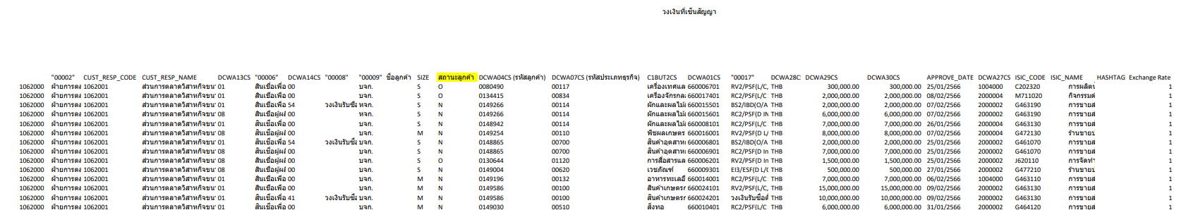

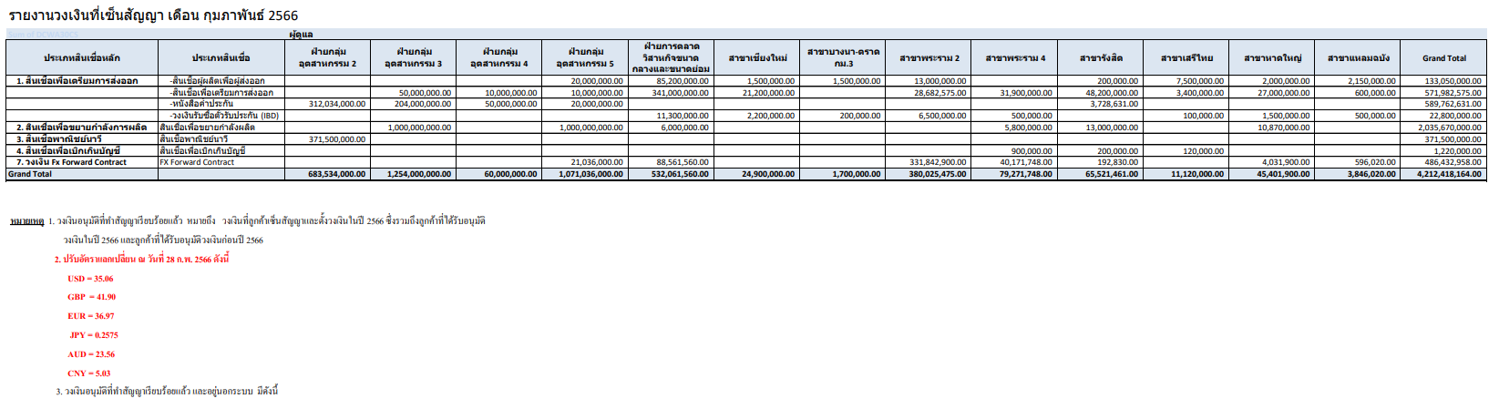

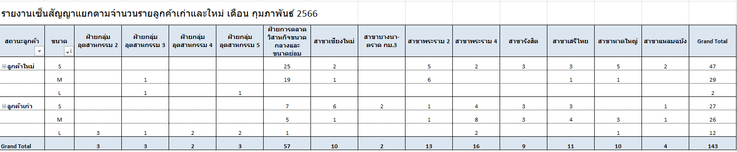

### Menu Modification

Not applicable

### Screen Layout and Data Sheet

Not Applicable

### Business Rule / Business Logic

| Paper Size | A4 |
| --- | --- |
| Reprinting Require | Yes |
| Searching Criteria | Period of Time (Monthly) |

### To-be Processing

The system will retrieve information from CBS Limits Facility function with details on:

* Limit summarized for the customer limit that sign contract completely in a given month
* The system will capture transaction code “Create Limit” and “Increase Limit” to this report
* For the transaction increase limit will show the amount of additional amount
* Description of products (Major/Minor) from business module static configuration set up screens
* Show limit transactions in approve 2 in Limit Facility and Loan account
* เพิ่มการ sum ยอดรวมวงเงินของ แต่ละประเภทสินเชื่อ, Marketing Code, Branch
* แนบตัวอย่างรายงาน

In order to link the loan account created along with the limit facility code that will be reflected in the report:

* System to use major/minor code in Loan level for the same customer where Agreement date falls within the specified month for report generation.

Loan account information retrieved from Narrative record of limit facility

### File /API Layout and Data Sheet

### Report Layout and Data Sheet

| Screen/Report Field Name/Attributes | Sample Data | Source/Validations |
| --- | --- | --- |
| Header |  |  |
| Title | Sign Contract Limit Report |  |
| Period of Time | 1-31 March 2023 |  |
| Printed Page | 1 |  |
| Printed Date | 3/04/23 |  |
| Printed Time | 19:08:11 |  |
| Program | CSCM4032 |  |
| User (Retrive Report) | SUPALUCKW |  |
| Details |  |  |
| Marketing Department Code | 1056000 |  |
| Marketing Department Description | ฝ่ายอุตสาหกรรม 2 |  |
| Marketing Segment Code | 1056001 |  |
| Marketing Segment Description | ส่วนอุตสาหกรรม 2.1 |  |
| Transaction Code | Create, Increase. |  |
| Business Size Code | 1 |  |
| Business Size | S small |  |
| Status | New, Old |  |
| Customer ID | 0106406 |  |
| Thai Title | หจก. |  |
| Customer Thai Name |  |  |
| Major Credit Code | 03 |  |
| Minor Credit Code | 00 |  |
| Major/Minor Description | สินเชื่อขยายกำลังการผลิต |  |
| Limit ID | 610175201 |  |
| Limit Description | Loan |  |
| Product Program | BIZ |  |
| Hashtag | #SCV |  |
| Credit Type | Specific Project Limit |  |
| Currency | THB, USD |  |
| Amount Limit | 1,000,000.00 |  |
| Amount Limit (THB) | 35,000,000.00 |  |
| Authorize No. | 49/2023 |  |
| Authorize Level | 84 Underwriting Committee |  |
| Authorize Date | 20/03/2023 |  |
| Contract Sign Date | 27/03/2023 |  |
| Operation Branch | Rama IV Branch |  |
| ISIC_Code | G463120 |  |
| ISIC_Name | การขายส่งปลาและผลิตภัณฑ์สัตว์น้ำ |  |
| Business Code | 00642 |  |
| Business Description | ผลิตภัณฑ์พลาสติกและพลาสติก |  |
|  |  |  |

### Additional Impacts

#### System Interface requirement /Integration

Not Applicable

#### Migration

Not Applicable

#### Fit/Gap Analysis Report

## Cancellation report

### Purpose

The report is generated for displaying the details on the limit movement, also another purpose for this report is to be the informative document for generating the report of accumulative report, report for submit NCB, and the NPL report followed by user.

แก้วัตถุประสงค์

### Background

#### EXIM Current Business Pracitce (as is)

* As is report produced in AS/400
* Sample report in Support Sample Transaction and Case from Customer section
* The system will capture transaction code “Cancel limit” to this report
* There are 2 ways to cancel the limit

1. The customer does not sign the contract

After cancel limit (old status verify 1), the system issues to cancel the monthly limit

1. The customer has signed the contract

After approve cancel the limit, the system issues to cancel the monthly limit

### Supported Sample Transaction and Case from Customer

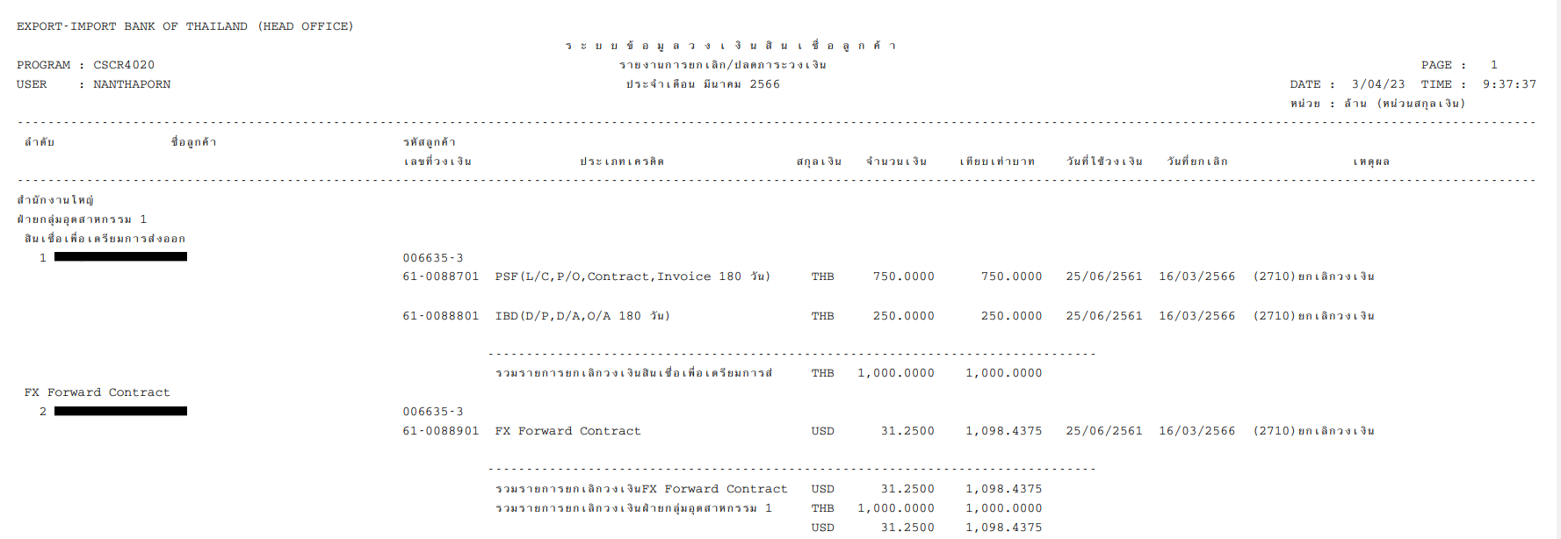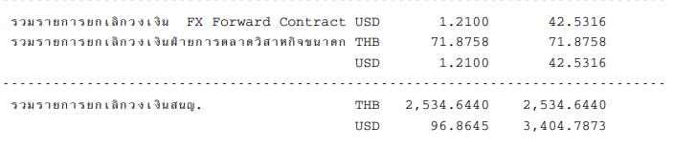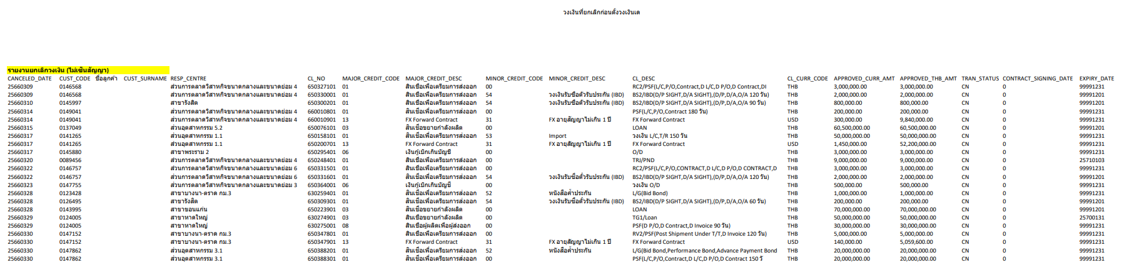

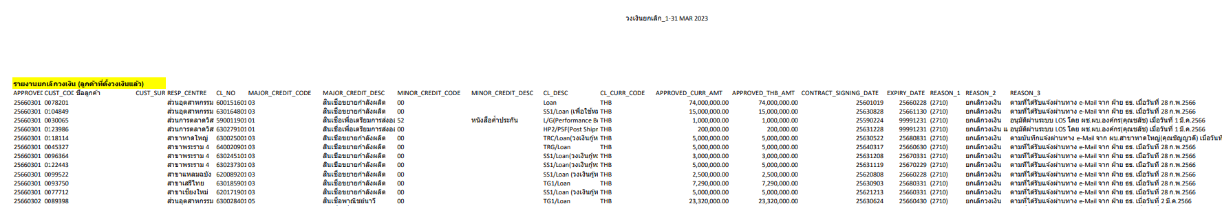

### Menu Modification

Not applicable

### Screen Layout and Data Sheet

Not Applicable

### Business Rule / Business Logic

The system will retrieve information from CBS Limits Facility function with details on:

* Limit information that will summarize the cancelled limit for customer
* The system will capture transaction code “Cancel Limit” to this report
* Show limit transactions in approve 1 in BPM (Limit Facility, Loan account for cancel limit not sign contract yet
* Show limit transactions in approve 2 in Limit Facility and Loan account for cancel limit sign contract
* Description of products (Major/Minor) from business module static configuration set up screens
* Other related information: Marketing information linked to customer, Thai Title name, etc.
* เพิ่มการ sum ยอดรวมวงเงิน
* แนบตัวอย่างรายงาน

### To-be Processing

| Paper Size | A4 |
| --- | --- |
| Reprinting Require | Yes |
| Searching Criteria | Period of Time (Monthly) |

### File /API Layout and Data Sheet

### Report Layout and Data Sheet

Not Sign Contract Yet

| Screen/Report Field Name/Attributes | Sample Data | Source/Validations |
| --- | --- | --- |
| Header |  |  |
| Title | Cancellation Report (Not sign contract) |  |
| Period of Time | 1-31 March 2023 |  |
| Printed Page | 1 |  |
| Printed Date | 3/04/23 |  |
| Printed Time | 19:08:11 |  |
| Program | CSCR4020 |  |
| User (Retrive Report) | SUPALUCKW |  |
| Details |  |  |
| Cancellation Date | 25660309 |  |
| Marketing Segment Code | 1056001 |  |
| Marketing Segment Description | ส่วนอุตสาหกรรม 2.1 |  |
| Transaction Code | Cancel |  |
| Customer ID | 0106406 |  |
| Thai Title | หจก. |  |
| Customer Thai Name |  |  |
| Major Credit Code | 03 |  |
| Minor Credit Code | 00 |  |
| Major/Minor Description | สินเชื่อขยายกำลังการผลิต |  |
| Limit ID | 610175201 |  |
| Limit Description | Loan |  |
| Product Program | BIZ |  |
| Credit Type | Specific Project Limit |  |
| Currency | THB, USD |  |
| Amount Limit | 1,000,000.00 |  |
| Amount Limit (THB) | 35,000,000.00 |  |
| Expiry Date | 99991231 |  |

Sign contract

| Screen/Report Field Name/Attributes | Sample Data | Source/Validations |
| --- | --- | --- |
| Header |  |  |
| Title | Cancellation Report (Sign contract) |  |
| Period of Time | 1-31 March 2023 |  |
| Printed Page | 1 |  |
| Printed Date | 3/04/23 |  |
| Printed Time | 19:08:11 |  |
| Program | CSCR4020 |  |
| User (Retrive Report) | SUPALUCKW |  |
| Details |  |  |
| Cancellation Date | 25660309 |  |
| Marketing Segment Code | 1056001 |  |
| Marketing Segment Description | ส่วนอุตสาหกรรม 2.1 |  |
| Transaction Code | Cancel |  |
| Customer ID | 0106406 |  |
| Thai Title | หจก. |  |
| Customer Thai Name |  |  |
| Major Credit Code | 03 |  |
| Minor Credit Code | 00 |  |
| Major/Minor Description | สินเชื่อขยายกำลังการผลิต |  |
| Limit ID | 610175201 |  |
| Limit Description | Loan |  |
| Product Program | BIZ |  |
| Credit Type | Specific Project Limit |  |
| Currency | THB, USD |  |
| Amount Limit | 1,000,000.00 |  |
| Amount Limit (THB) | 35,000,000.00 |  |
| Expiry Date | 99991231 |  |
| Cancellation Date | 25660309 |  |
| Remark 1 | 2710 |  |
| Remark 2 | ยกเลิกวงเงิน |  |
| Remark 3 | อนุมัติโดย |  |

### Additional Impacts

#### System Interface requirement /Integration

Not Applicable

#### Migration

Not Applicable

#### Fit/Gap Analysis Report

## Not sign contract report

### Purpose

The report is generated for illustrating the customer that have approved the limit but not sign the contract yet. This report will be sent to others department for monitoring the customer contract signing.

### Background

#### EXIM Current Business Pracitce (as is)

* As is report produced in AS/400
* Sample report in Support Sample Transaction and Case from Customer section
* Displays all credit limits verify 1 and does not yet have a contract sign date

### Supported Sample Transaction and Case from Customer

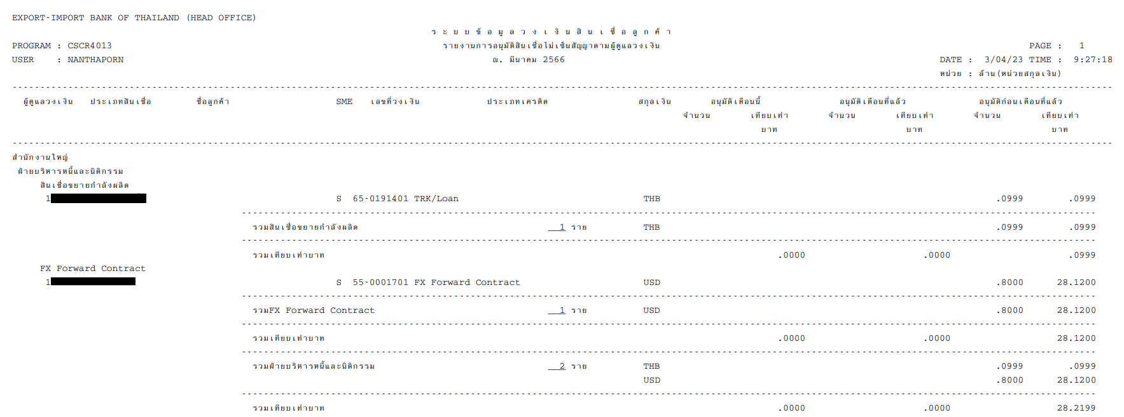

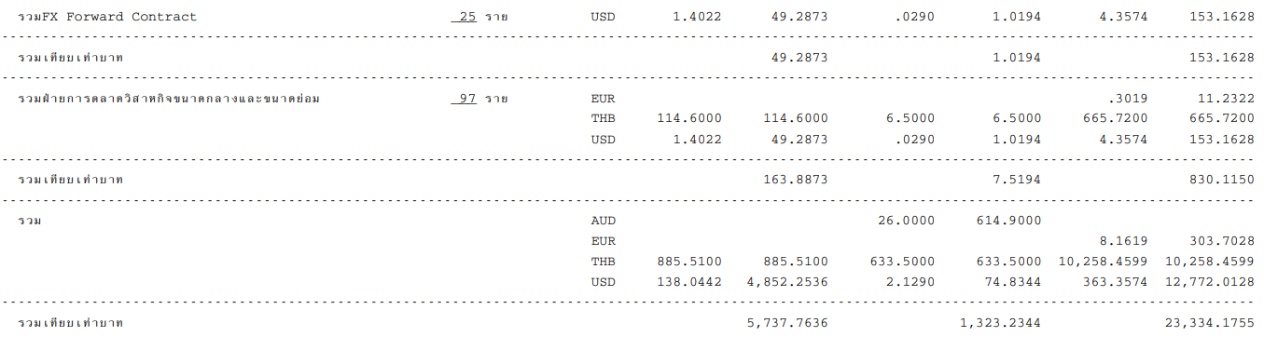

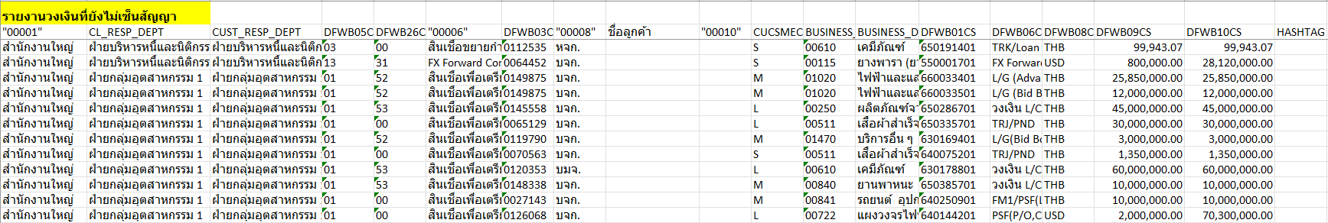

### Menu Modification

Not applicable

### Screen Layout and Data Sheet

Not Applicable

### Business Rule / Business Logic

The system will retrieve information from CBS Limits Facility function with details on:

* Limit information where Limit Facility Verified Flag is set to N
* Show all limit transactions in approve 1 in BPM (Limit Facility, Loan account)
* Description of products (Major/Minor) from business module static configuration set up screens
* Other related information: Marketing information linked to customer, Thai Title name, etc.
* เพิ่มการ sum ยอดของวงเงิน, ประเภทสินเชื่อ, Marketing Code, Branch
* แนบตัวอย่างรายงาน

### To-be Processing

| Paper Size | A4 |
| --- | --- |
| Reprinting Require | Yes |
| Searching Criteria | Period of Time (Monthly) |

### File /API Layout and Data Sheet

### Report Layout and Data Sheet

| Screen/Report Field Name/Attributes | Sample Data | Source/Validations |
| --- | --- | --- |
| Header |  |  |
| Title | Not Sign Contract Report |  |
| Period of Time | As at 31 March 2023 |  |
| Printed Page | 1 |  |
| Printed Date | 3/04/23 |  |
| Printed Time | 19:08:11 |  |
| Program | CSCR4013 |  |
| User (Retrive Report) | SUPALUCKW |  |
| Details |  |  |
| Marketing Department Code | 1056000 |  |
| Marketing Department Description | ฝ่ายอุตสาหกรรม 2 |  |
| Marketing Segment Code | 1056001 |  |
| Marketing Segment Description | ส่วนอุตสาหกรรม 2.1 |  |
| Transaction Code | Create, Increase |  |
| Customer ID | 0106406 |  |
| Thai Title | หจก. |  |
| Customer Thai Name |  |  |
| Major Credit Code | 03 |  |
| Minor Credit Code | 00 |  |
| Major/Minor Description | สินเชื่อขยายกำลังการผลิต |  |
| Business Size Code | 2 |  |
| Business Size | M |  |
| Business Code | 00610 |  |
| Business Description | เคมีภัณฑ์ |  |
| Limit ID | 610175201 |  |
| Limit Description | Loan |  |
| Product Program | BIZ |  |
| Credit Type | Specific Project Limit |  |
| Currency | THB, USD |  |
| Amount Limit | 1,000,000.00 |  |
| Amount Limit (THB) | 35,000,000.00 |  |
| Authorize No. | 49/2023 |  |
| Authorize Level | 84 Underwriting Committee |  |
| Authorize Date | 20/02/2023 |  |
| Hashtag | #EEC |  |

### Additional Impacts

#### System Interface requirement /Integration

Not Applicable

#### Migration

Not Applicable

#### Fit/Gap Analysis Report

## Limit and outstanding report

### Purpose

This report is generated for summarize the accumulative credit limit of all customers who have a credit line with the bank until now. By comparing it with the customer's outstanding balance. Classified by business type (Ministry of Commerce) by checking the outstanding balance to match the trial balance of the Accounting Department.

### Background

#### EXIM Current Business Pracitce (as is)

* As is report prepared *manually*
* Sample report in Support Sample Transaction and Case from Customer section

### Supported Sample Transaction and Case from Customer

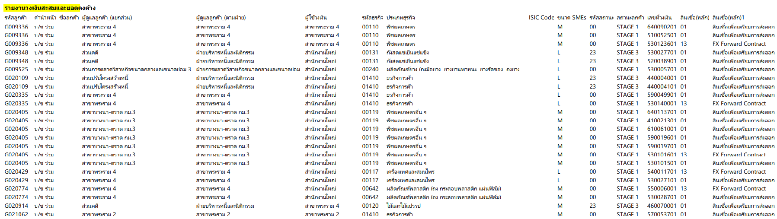

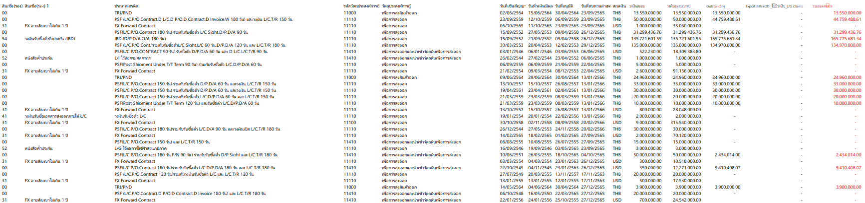

### Menu Modification

Not applicable

### Screen Layout and Data Sheet

Not Applicable

### Business Rule / Business Logic

* Limit perspective
* Show overall outstanding limit amount per customer and limit facility code:
  + In the event limit facility is in Foreign currency, oustanding amount will be converted to THB using prevailing conversion rate of Limit module exchange rate type
* GL Outstanding
* Show overall outstanding of customer using Asset GL Code used during drawdown event given the same major/minor code used to hit the limit facility which corresponds to loan type/loan sub type set up in Loan Accounting table

### To-be Processing

| Paper Size | A4 |
| --- | --- |
| Reprinting Require | Yes |
| Searching Criteria | Period of Time (Monthly) |

### File /API Layout and Data Sheet

### Report Layout and Data Sheet

| Screen/Report Field Name/Attributes | Sample Data | Source/Validations |
| --- | --- | --- |
| Details |  |  |
| Marketing Department Code | 1056000 |  |
| Marketing Department Description | ฝ่ายอุตสาหกรรม 2 |  |
| Marketing Segment Code | 1056001 |  |
| Marketing Segment Description | ส่วนอุตสาหกรรม 2.1 |  |
| Operation Branch | Rama IV Branch |  |
| Transaction Code | Create, Increase |  |
| Customer ID | 0106406 |  |
| Thai Title | หจก. |  |
| Customer Thai Name |  |  |
| Major Credit Code | 04 |  |
| Minor Credit Code | 00 |  |
| Major/Minor Description | สินเชื่อโครงการระหว่างประเทศ |  |
| Limit ID | 610175201 | Loan & OD Limit Facility |
| Limit Description | Loan |  |
| Credit Type | Specific Project Limit |  |
| Product Program | BIZ |  |
| Main Purpose Code | 11000 |  |
| Main Purpose Description | เพื่อการส่งออก |  |
| Business Size Code | 2 |  |
| Business Size | M |  |
| Status Code | 00 and 23 |  |
| Status Description | Stage 1 and Stage 3 |  |
| Business Code | 00610 |  |
| Business Description | เคมีภัณฑ์ |  |
| ISIC Code | C107720 |  |
| Sign Contract | 02/06/2023 |  |
| Effective Date | 15/06/2023 |  |
| Approval Date | 30/05/2023 |  |
| Check Limit Date | 23/09/2023 |  |
| Currency | THB, USD |  |
| Amount Limit | 1,000,000.00 USD |  |
| Amount Limit (THB) | 35,000,000.00 THB |  |
| Oustanding (THB) | 35,000,000.00 THB | This report to include only:  Loan and OD facilities.  Loan account to be included.  For Deposit Accounts, in the event balance is <0, it should be part of the report, limit id to be null or not applicable as client does was not granted limit facility |
| Oustanding with no limits (OD, LG Claim)*** | - |  |
| Total Oustanding | 35,000,000.00 THB |  |
| Contingent (LC, DLC)*** |  | Trade Finance accounts not applciable |
| Contingent LG*** |  | Trade Finance accounts not applciable |
| Approval Limit | 1,000,000.00 USD |  |
| Accumulate Credit Limit (THB) | 35,000,000.00 THB | Refer to excel file from sharepoint |
| Hold Available Existing*** |  |  |
| Rating Year | 2019 |  |
| Rating Type | R |  |
| Financial Grade | C1 |  |
| Financial % | 40 |  |
| Business Grade | B1 |  |
| Business % | 75 |  |
| Industry Grade | B |  |
| Industry % | 61 |  |
| Composite Grade | B4 |  |
| Composite % | 0 |  |
| Financial Composite Rating | B4 |  |
| AMLO Rating | A1 |  |

### Additional Impacts

#### System Interface requirement /Integration

Not Applicable

#### Migration

Not Applicable

#### Fit/Gap Analysis Report

Not Applicable

## Revolving credit limit (According to the limit user) report (Included in TOR, have to discuss)

### Purpose

This report is generated for summarize only revolving accumulative credit limit amount which classified by branches

### Background

#### EXIM Current Business Pracitce (as is)

* As is report prepared *manually*
* Sample report in Support Sample Transaction and Case from Customer section

### Supported Sample Transaction and Case from Customer

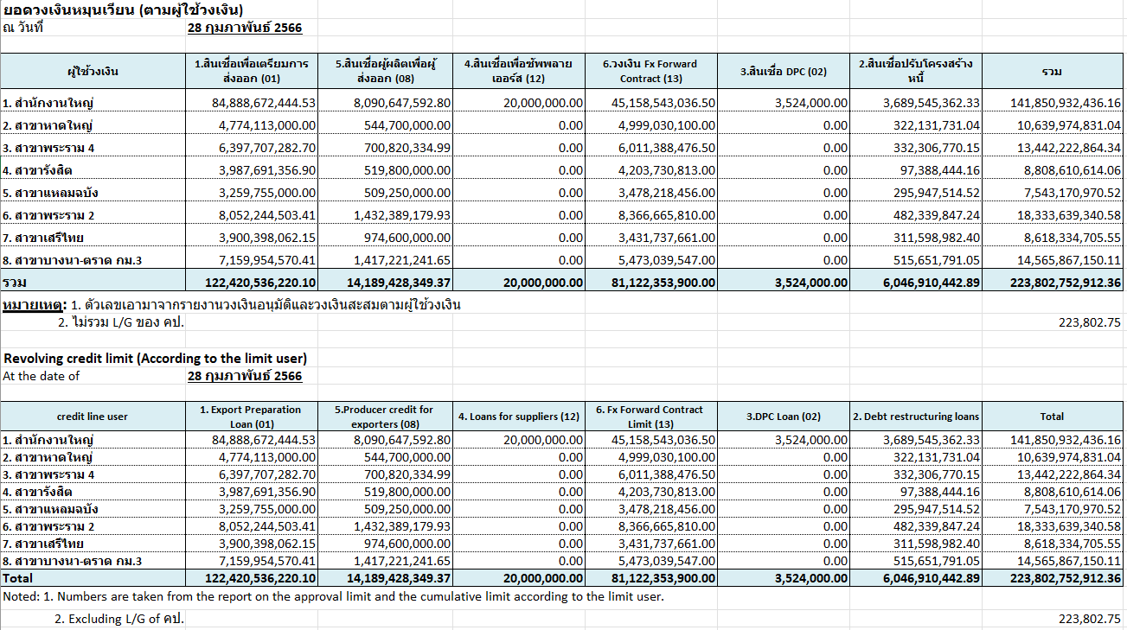

### Menu Modification

Not applicable

### Screen Layout and Data Sheet

Not Applicable

### Business Rule / Business Logic

The system will retrieve information from CBS Limits Facility function with details on:

* Limit Facility information where Limit Facility Revolving flag is set to Y
* Overall Outstanding by Limit Facility / product/domain grouped by Branches
* Total by Branch and by Product

### To-be Processing

| Paper Size | A4 |
| --- | --- |
| Reprinting Require | Yes |
| Searching Criteria | Period of Time (Monthly) |

### File /API Layout and Data Sheet

### Report Layout and Data Sheet

| Screen/Report Field Name/Attributes | Source/Validations |
| --- | --- |
| Header | |
| Revolving Credit Limit (According to limit user) |  |
| At the date of |  |
| Detail | |
| Credit Line User |  |
| Export Prepration |  |
| Producer Credit for Exporters |  |
| Loan for suppliers |  |
| FX Forward Contract |  |
| DPC Loan |  |
| Debt Restructuring |  |
| Total |  |
|  |  |
|  |  |
|  |  |
|  |  |
|  |  |
|  |  |

### Additional Impacts

#### System Interface requirement /Integration

Not Applicable

#### Migration

Not Applicable

#### Fit/Gap Analysis Report

Not Applicable

## Report of the Accumulate Credit Limit Amount Summary Report (Included in TOR, have to discuss)

### Purpose

### Background

#### EXIM Current Business Pracitce (as is)

* As is report prepared *manually*
* Sample report in Support Sample Transaction and Case from Customer section

### Supported Sample Transaction and Case from Customer

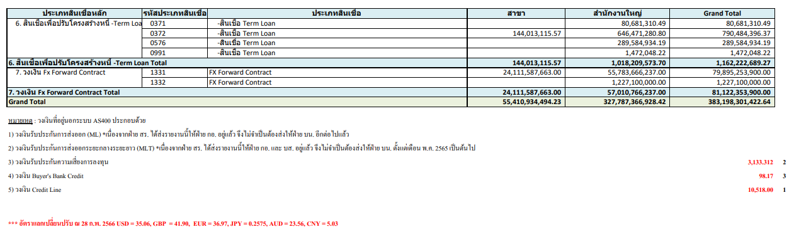

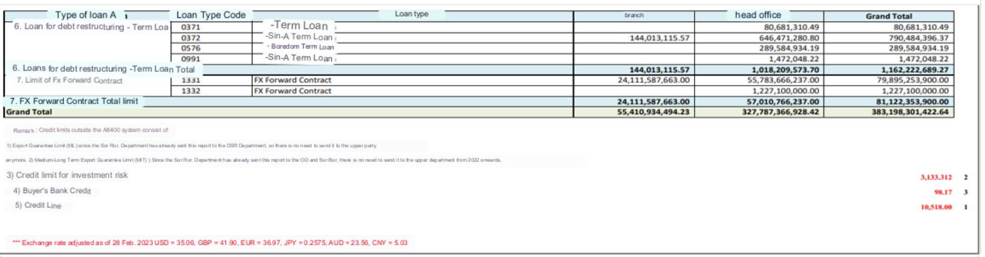

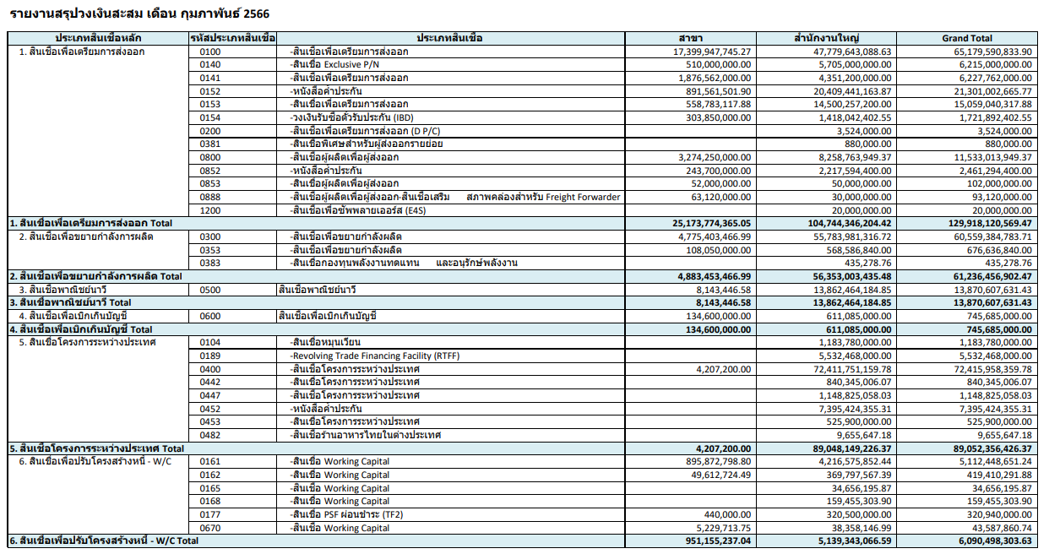

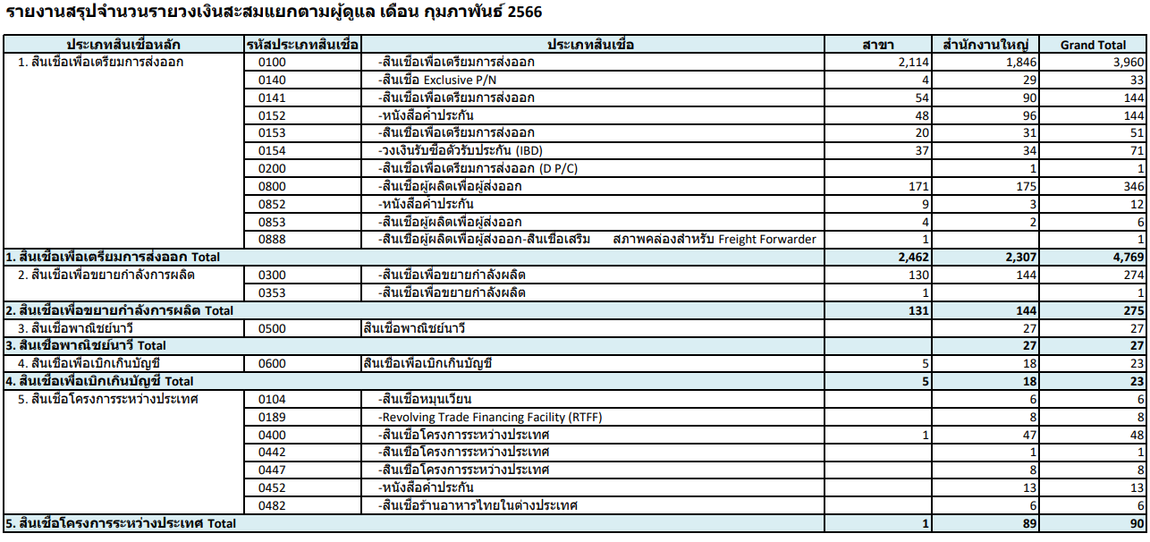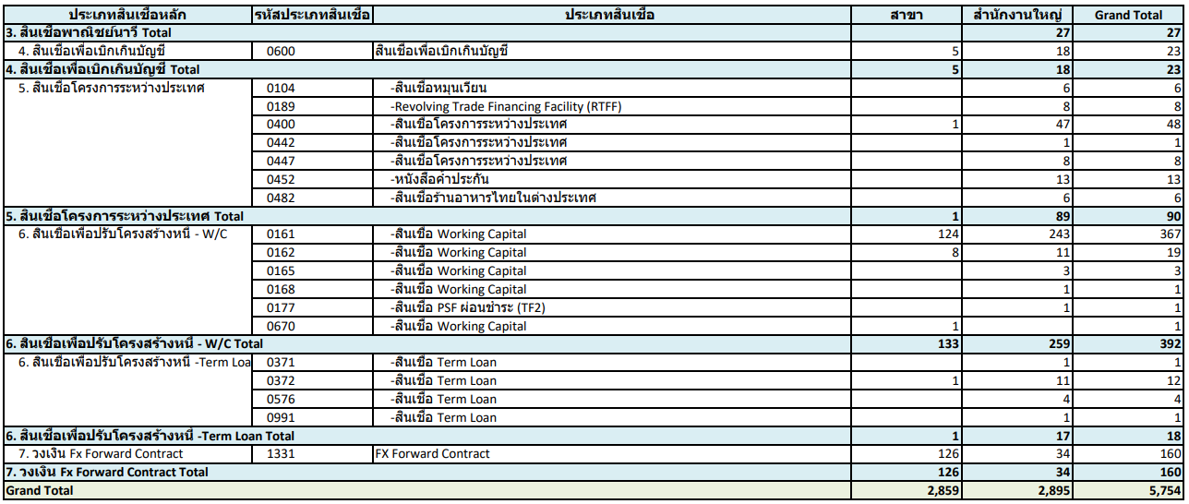

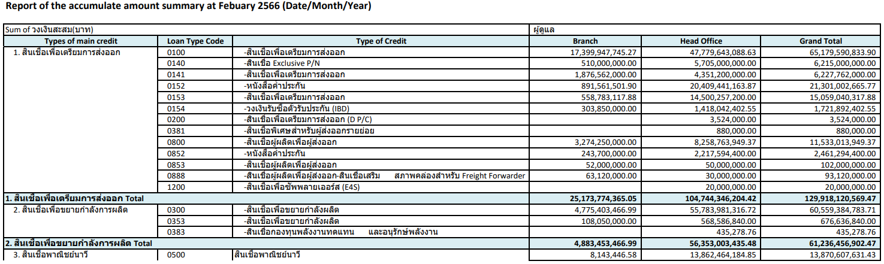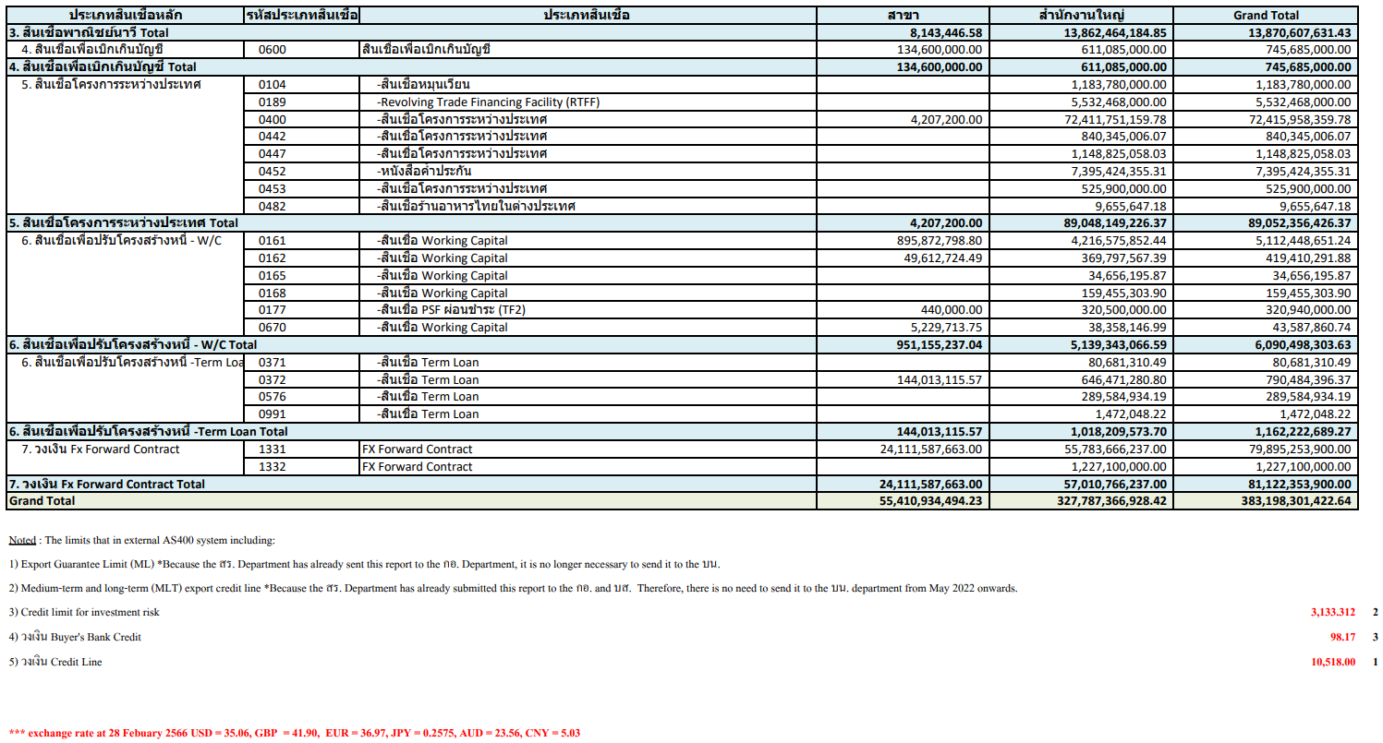

### Menu Modification

Not applicable

### Screen Layout and Data Sheet

Not Applicable

### Business Rule / Business Logic

The system will retrieve information from CBS Limits Facility function with details on:

* Limit Facility information where accumulative limit amount by credit limit facility grouped by branch, limit facility, product code (major/minor)

### To-be Processing

| Paper Size | A4 |
| --- | --- |
| Reprinting Require | Yes |
| Searching Criteria | Adhoc |

### File /API Layout and Data Sheet

### Report Layout and Data Sheet

| Screen/Report Field Name/Attributes | Source/Validations |
| --- | --- |
| Type of main credit |  |
| Loan Type Code |  |
| Type of Credit |  |
| Branch |  |
| Head Office |  |
| Grand Total |  |
|  |  |

### Additional Impacts

#### System Interface requirement /Integration

Not Applicable

#### Migration

Not Applicable

#### Fit/Gap Analysis Report

## Summary report of business types (Included in TOR, have to discuss)

### Purpose

### Background

#### EXIM Current Business Pracitce (as is)

* As is report prepared *manually*
* Sample report in Support Sample Transaction and Case from Customer section

### Supported Sample Transaction and Case from Customer

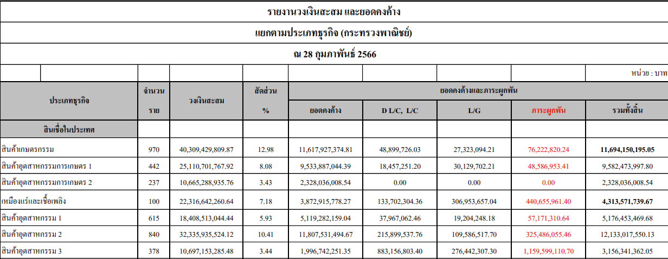

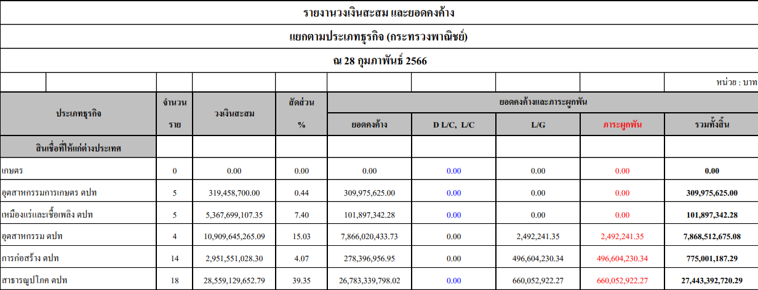

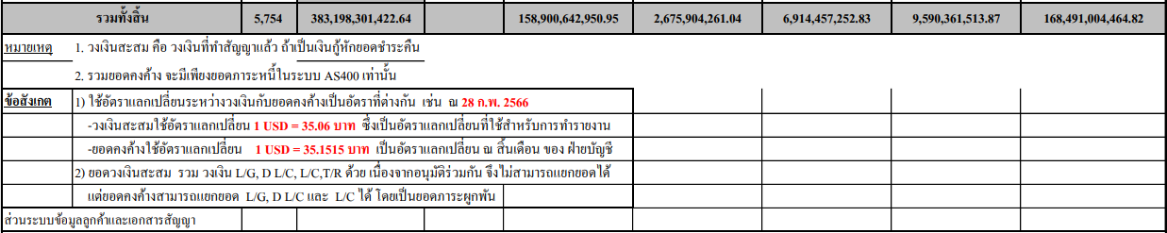

### Menu Modification

Not applicable

### Screen Layout and Data Sheet

Not Applicable

### Business Rule / Business Logic

The system will retrieve information from CBS Limits Facility function with details on:

* Sum of outstanding limit amount by Product (grouped by Major/Minor), Branches

### To-be Processing

### File /API Layout and Data Sheet

### Report Layout and Data Sheet

| Screen/Report Field Name/Attributes | Source/Validations |
| --- | --- |
|  |  |
|  |  |
|  |  |
|  |  |
|  |  |
|  |  |
|  |  |

### Additional Impacts

#### System Interface requirement /Integration

Not Applicable

#### Migration

Not Applicable

#### Fit/Gap Analysis Report

Not Applicable

## Risk Weight report

### Purpose

The report is generated for display the limit accumulative details about credit limit between countries which include country of risk, country risk weight, and limit exposure.

### Background

#### EXIM Current Business Pracitce (as is)

* As is report prepared *manually*
* Sample report in Support Sample Transaction and Case from Customer section

### Supported Sample Transaction and Case from Customer

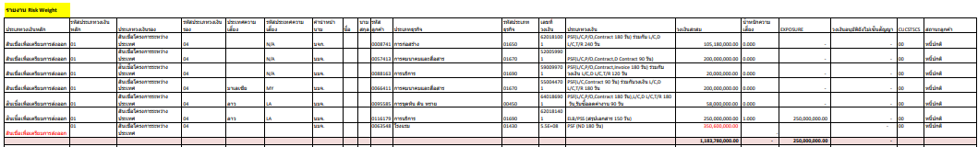

### Menu Modification

Not applicable

### Screen Layout and Data Sheet

Not Applicable

### Business Rule / Business Logic

The system will retrieve information from CBS Limits Facility function with details on:

* Limit Facility information where accumulative limit amount by credit limit facility grouped by branch, limit facility, product code (major/minor)

### To-be Processing

| Paper Size | A4 |
| --- | --- |
| Reprinting Require | Yes |
| Searching Criteria | Only the limit that include country of risk, ratio of risk and will generate report as monthly. |

### File /API Layout and Data Sheet

### Report Layout and Data Sheet

| Screen/Report Field Name/Attributes | Source/Validations |
| --- | --- |
| Details |  |
| Product Type |  |
| Product Sub Type |  |
| Country of Risk |  |
| Country Code |  |
| Thai Title |  |
| Customer First Name |  |
| Customer Surname |  |
| Customer ID | 0106406 |
| Type of Business |  |
| Type of Business Code |  |
| Limit ID |  |
| Limit Type |  |
| Accumulative Limit Amount |  |
| Ratio of Risk |  |
| Exposure | Accumulative Limit Amount * Ratio of Risk |
| Approved Limit but Unsigned Contract |  |
| Customer Status Code |  |
| Description of Customer Status |  |
|  |  |
| Thai Title | หจก. |
| Customer Thai Name |  |
| Major Credit Code | 04 |
| Minor Credit Code | 00 |
| Major/Minor Description | สินเชื่อโครงการระหว่างประเทศ |
| Country of Risk | MY Malaysia |
| Ratio of Risk | 1.000 |
| Limit ID | 610175201 |
| Limit Description | Loan |
| Product Program | BIZ |
| Currency | THB, USD |
| Amount Limit | 1,000,000.00 |
| Accumulate Amount Limit (THB) | 35,000,000.00 |
| Exposure | 35,000,000.00 |
| Authorize No. | 49/2022 |
| Authorize Level | 84 Underwriting Committee |
| Authorize Date | 28/11/2022 |
| Contract Sign Date | 30/11/2022 |
| Status Code | 00, 23 |
| Status Description | Stage 1, Stage 3 |
| Not sign contract of approved limit | - |

### Additional Impacts

#### System Interface requirement /Integration

Not Applicable

#### Migration

Not Applicable

#### Fit/Gap Analysis Report

Not Applicable

## Loan amount that have not drawdown report (classified by credit line users)

### Purpose

The report is generated to summarize the Loan amount that have not drawdown report (classified by credit line users) as the example of excel layout will be generated by user manually

### Background

Loan Credit Limit Report will be related with Lending team which referred to LND_FS_Report

For the summary of Loan amount that have not drawdown report (classified by credit line users) as the example of excel layout will be generated by user manually

### Supported Sample Transaction and Case from Customer

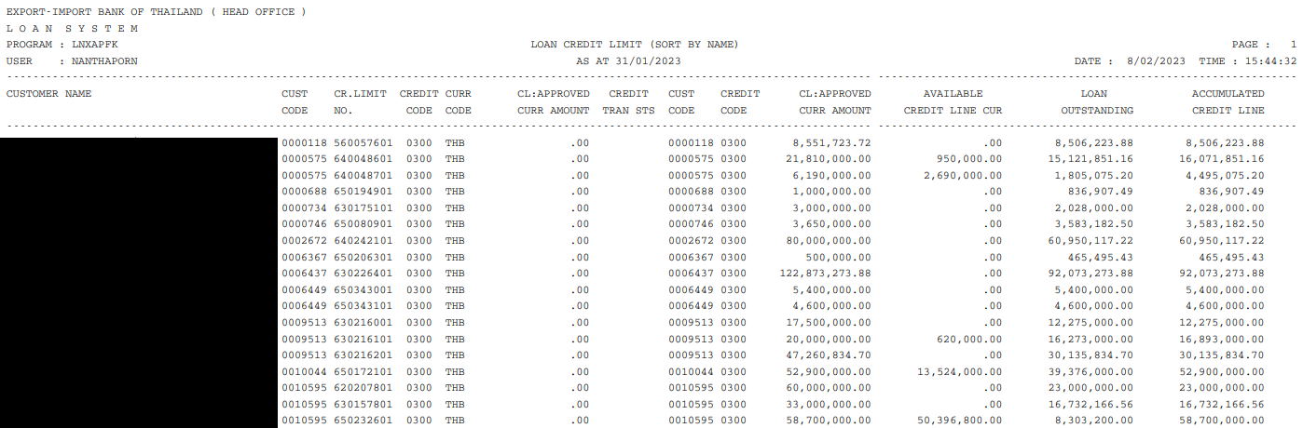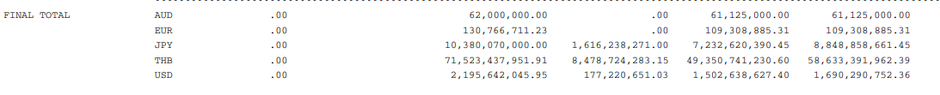

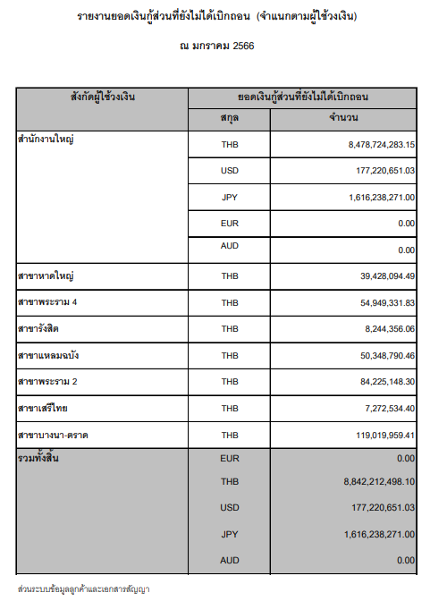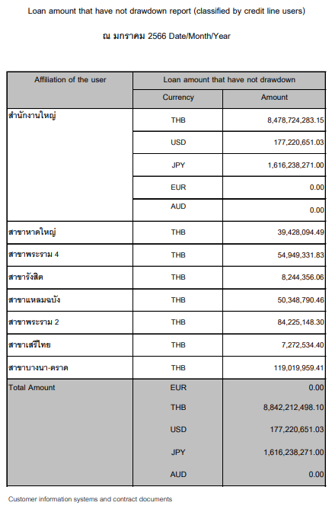

Overall total by branch, currency

### Menu Modification

Not applicable

### Screen Layout and Data Sheet

Not Applicable

### Business Rule / Business Logic

Report logic process for that have not been drawn will be based on:

1. Loan record where created date is within the specified report criteria Month + corresponding loan account having the same major/minor code of the limit facility code.
2. Loan record Available Amount = Loan amount
3. Overall total to be derived based on loan currency

### To-be Processing

| Paper Size | A4 |
| --- | --- |
| Reprinting Require | Yes |
| Searching Criteria | Operation Department (Head Office, Branch) |

For the summary of Loan amount that have not drawdown report (classified by credit line users), the system will generate by summarizing the loan amount that not drawdown based on classification of operation departments code and branch code.

### File /API Layout and Data Sheet

### Report Layout and Data Sheet

| Screen/Report Field Name/Attributes | Sample Data | Source/Validations |
| --- | --- | --- |
| Header |  |  |
| Title | Loan Credit Limit Report |  |
| Period of Time | AS of 31/01/2023 |  |
| Printed Page | 1 |  |
| Printed Date | 3/04/23 |  |
| Printed Time | 19:08:11 |  |
| Program | LNXAPFK |  |
| Details |  |  |
| Operation Department Code | 1004000 |  |
| Operation Department Description | Head Office |  |
| Customer ID | 0106406 |  |
| Customer Thai Name |  |  |
| Major Credit Code | 03 |  |
| Minor Credit Code | 00 |  |
| Major/Minor Description | สินเชื่อขยายกำลังการผลิต |  |
| Limit ID | 610175201 |  |
| Currency | THB, USD |  |
| Amount Limit | 1,000,000.00 USD |  |
| CL: Approved Currency Amount | 1,000,000.00 USD |  |
| Credit Tran STS |  |  |
| Available Credit Lime Currency | 100,000 USD |  |
| Loan Outstanding | 900,000 USD |  |
| Accumulated Credit Line | 900,000 USD |  |
| Total Final (Based on currency) |  |  |
| Total By Credit Type |  |  |

**Loan amount that have not drawdown report (classified by credit line users) [excel layout]**

| Screen/Report Field Name/Attributes | Sample Data | Source/Validations |
| --- | --- | --- |
| Header |  |  |
| Title | Loan amount that have not drawdown report (classified by credit line users) |  |
| Period of Time | AS of 31/01/2023 |  |
|  |  |  |
|  |  |  |
| Details |  |  |
| Operation Department Code | 1004000 |  |
| Operation Department Description | Head Office |  |
| Currency | THB, USD |  |
| Available Credit Limit Currency | 100,000 USD |  |
| Total Final (Based on currency) |  |  |
| Grand Total (Based on currency) |  |  |

### Additional Impacts

#### System Interface requirement /Integration

Not Applicable

#### Migration

Not Applicable

#### Fit/Gap Analysis Report

## Decreasing Limits report

### Purpose

The report is generated for displaying the details on the limit movement (decreased limit), also another purpose for this report is to be the informative document for generating the report of accumulative report, report for submit NCB, and the NPL report followed by user.

### Background

#### EXIM Current Business Pracitce (as is)

* As is report prepared *manually*
* Sample report in Support Sample Transaction and Case from Customer section

### Supported Sample Transaction and Case from Customer

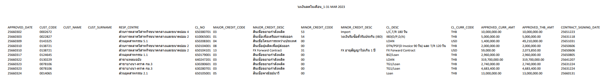

### Menu Modification

Not applicable

### Screen Layout and Data Sheet

Not Applicable

### Business Rule / Business Logic

As basis of generating the report, the system will retrieve information from CBS Limits Facility function with details on:

* Limit Facility Details where decrease limit was performed for the given specified period

### To-be Processing

| Paper Size | A4 |
| --- | --- |
| Reprinting Require | Yes |
| Searching Criteria | Period of Time (Weekly) |

### File /API Layout and Data Sheet

### Report Layout and Data Sheet

| Screen/Report Field Name/Attributes | Sample Data | Source/Validations |
| --- | --- | --- |
| Header |  |  |
| Title | Cancellation/Decrease Report |  |
| Period of Time | 1-31 March 2023 |  |
| Printed Page | 1 |  |
| Printed Date | 3/04/23 |  |
| Printed Time | 19:08:11 |  |
| Program | CSCR4020 |  |
| User (Retrive Report) | SUPALUCKW |  |
| Details |  | Same as decreased limit (credit advice report) only that this is based on decreased limit for a given month |
| Approve Date | 25660309 |  |
| Marketing Segment Code | 1056001 |  |
| Marketing Segment Description | ส่วนอุตสาหกรรม 2.1 |  |
| Transaction Code | Decrease |  |
| Customer ID | 0106406 |  |
| Thai Title | หจก. |  |
| Customer Thai Name |  |  |
| Major Credit Code | 03 |  |
| Minor Credit Code | 00 |  |
| Major/Minor Description | สินเชื่อขยายกำลังการผลิต |  |
| Limit ID | 610175201 |  |
| Limit Description | Loan |  |
| Product Program | BIZ |  |
| Credit Type | Specific Project Limit |  |
| Currency | THB, USD |  |
| Amount Limit | 1,000,000.00 |  |
| Amount Limit (THB) | 35,000,000.00 |  |
| Expiry Date | 99991231 |  |
| Contract sign date | 25660105 |  |
| Remark 1 | 2710 |  |
| Remark 2 | ลดวงเงิน |  |
| Remark 3 | อนุมัติโดย |  |

### Additional Impacts

#### System Interface requirement /Integration

Not Applicable

#### Migration

Not Applicable

#### Fit/Gap Analysis Report

Not Applicable

## Report Reconcile

### Purpose

### Background

### Supported Sample Transaction and Case from Customer

### Menu Modification

Not applicable

### Screen Layout and Data Sheet

Not Applicable

### Business Rule / Business Logic

### To-be Processing

### File /API Layout and Data Sheet

### Report Layout and Data Sheet

Note: Type - M (Mandatory), O (Optional), C (Conditional), A (Amend), D (Display), Q (Query)

| Screen/Report Field Name/Attributes | Source/Validations |
| --- | --- |
|  |  |
|  |  |
|  |  |
|  |  |
|  |  |
|  |  |

### Additional Impacts

#### System Interface requirement /Integration

Not Applicable

#### Migration

Not Applicable

#### Fit/Gap Analysis Report

Not Applicable